ABSTRACT
This statistical project focuses on analyzing student performance in weekly quizzes through the application of Bernoulli and Binomial probability models. Each student's quiz outcome is categorized as a Bernoulli trial, representing either a success (pass) or failure. By tracking these outcomes over several weeks, we accumulate data to model the total number of passes using the Binomial distribution. The primary objective is to calculate the probability of success (i.e., passing the quiz) for individual students and the group as a whole. This helps in identifying the average performance level, detecting patterns over time, and analyzing variability among different students. Moreover, the project investigates trends such as improvement, consistency, or decline in quiz scores, offering valuable insights into the effectiveness of teaching methods and the relative difficulty of quizzes. Through this approach, educators and administrators can make data-driven decisions to enhance instructional strategies, design better assessments, and provide targeted support for students who may be struggling. The findings contribute to improving academic outcomes by promoting a deeper understanding of student learning behaviors and performance dynamics.

CHAPTER 1
INTRODUCTION

1.1 BACKGROUND OF THE STUDY
In modern education, weekly quizzes have become an essential part of continuous assessment in colleges and universities. These quizzes are designed to test a student’s understanding of the subject matter in small segments rather than waiting for mid-term or end-term examinations. Each quiz provides immediate feedback to both students and teachers about learning progress. However, it is observed that students’ performances are not uniform; while some students consistently pass the quizzes, others often fail or perform inconsistently. This variation is natural because learning and understanding vary from student to student, and different factors such as preparation, confidence, and prior knowledge play a role in determining outcomes.
From a statistical perspective, each quiz attempt can be considered a Bernoulli trial, where the outcome is binary: either success (the student passes) or failure (the student fails). By observing these outcomes over several quizzes, it is possible to apply the Binomial probability distribution to analyze the frequency of successes over repeated trials. For instance, if a student takes four quizzes in a month, and the probability of passing a single quiz is 0.7, the Binomial distribution can calculate the probability that the student passes exactly three quizzes. Such mathematical modeling helps to predict the number of students likely to pass, understand performance trends, and identify areas where additional support might be necessary.
This study connects statistical theory with practical classroom outcomes. It not only demonstrates the application of probability models in education but also provides insights into students’ learning behavior. By analyzing weekly quiz results using Bernoulli and Binomial models, teachers can understand patterns of success and failure, and students can gauge their learning progress objectively. Furthermore, this approach encourages a data-driven understanding of academic performance, moving beyond subjective impressions and anecdotal observations.
Additionally, studying probability in the context of quizzes makes learning mathematics more relatable and practical. Students often perceive probability as an abstract concept, but when applied to something familiar, such as quizzes they take every week, it becomes tangible and meaningful. The analysis also helps in identifying trends in consistent performers versus those whose performance fluctuates, providing a foundation for personalized learning strategies. Overall, this study emphasizes the integration of statistical modeling with educational practice, showing that probability is not only a theoretical concept but also a practical tool for improving academic outcomes.
  - STATEMENT OF THE PROBLEM
Every semester, students participate in weekly quizzes that are designed to monitor learning progress. Despite the frequency of these assessments, it is often difficult for educators to predict how many students will succeed in any given quiz. Some students consistently perform well, while others show erratic or poor performance. This variability introduces uncertainty in understanding learning patterns and planning remedial instruction. The central problem, therefore, is the inability to measure and predict student performance in a systematic, statistical way.
Each quiz can be conceptualized as a Bernoulli trial, where a student either passes (success) or fails (failure). When these trials are repeated across several quizzes, the resulting data can be analyzed using the Binomial distribution to estimate probabilities of multiple successes. However, there are practical challenges: not all students have the same preparation level, confidence, or study habits, and quizzes may vary in difficulty. Consequently, raw results alone do not provide sufficient insight into performance trends or probability of success.
By framing this problem within probability theory, the study aims to provide a more systematic approach to understanding quiz outcomes. It seeks to answer questions such as: What is the likelihood of a student passing a given number of quizzes in a month? How consistent are students over time? Which factors, such as confidence or review habits, significantly influence success probabilities? Addressing these questions using Bernoulli and Binomial models allows teachers to anticipate performance trends, offer targeted guidance, and better support students who may be at risk.
Furthermore, the study also considers secondary factors such as review practices, preparation strategies, and the use of past quizzes for study. For instance, students who regularly review mistakes tend to have higher probabilities of success. By incorporating these observations into a probabilistic model, the research provides a comprehensive view of both the academic and behavioral factors affecting performance. In essence, the problem is not just about identifying failing students but about understanding patterns of success and failure, and using probability as a tool to interpret and predict educational outcomes accurately. Primary data indicates that factors such as lack of preparation, nervousness, and inconsistent study habits contribute to lower success rates. For instance, about 55% of students reported failing a quiz due to insufficient preparation, while 25% cited stress and nervousness as the main reason.
  - PURPOSE OF THE STUDY
The purpose of this study is to apply Bernoulli and Binomial probability models to real-world classroom data, specifically weekly quiz results. Rather than looking at raw marks alone, the study aims to examine the likelihood of success (passing) for individual students over repeated quizzes. This approach provides a clearer picture of academic consistency, performance trends, and areas needing improvement.
Another key purpose is to provide students and teachers with actionable insights. Students can evaluate their own chances of success and adjust study strategies accordingly. Teachers can use the probability analysis to identify students who might require additional support and to plan instructional strategies that improve overall learning outcomes. For example, if the probability of passing increases week by week, it may indicate that students are gradually improving their understanding and applying feedback effectively.
Additionally, the study seeks to bridge the gap between theoretical probability and practical application in education. By demonstrating the use of Bernoulli and Binomial models in a familiar context, the research shows how mathematical concepts can have tangible benefits in academic planning and performance evaluation. The study also encourages the use of data-driven decision making in classrooms, moving beyond subjective assessment and intuition.
Finally, the research aims to motivate students to appreciate the practical value of probability theory. When students see that their quiz performance can be analyzed mathematically and that patterns emerge, it fosters a sense of awareness and responsibility towards their learning. It also shows that performance improvement is measurable and achievable, further reinforcing the importance of consistent effort and systematic study habits.
The study also seeks to understand the relationship between quiz performance and other factors, such as confidence, preparation, and review habits. For example, the data shows that students who regularly review mistakes have a higher likelihood of passing subsequent quizzes. Similarly, students who use past quizzes for practice tend to show gradual improvement over the month.
Finally, the study aims to highlight the importance of consistent effort and structured study habits. By observing repeated quiz outcomes, the research demonstrates that steady practice and effective learning strategies significantly increase the probability of success.

  - AIM AND OBJECTIVES OF THE STUDY
Aim:
The study aims to analyze students’ weekly quiz performance using Bernoulli and Binomial probability models to determine the likelihood of passing, identify trends, and evaluate consistency over time.
Objectives:
- To interpret quiz outcomes as probability events with two possible results: pass or fail.
- To calculate probabilities of passing multiple quizzes using the Binomial formula.
- To evaluate consistency and fluctuation in student performance.
- To analyze the effect of confidence, review habits, and preparation on success probability.
- To demonstrate the practical application of probability models in academic evaluation.
- To provide practical recommendations for students and educators to enhance performance in weekly quizzes.
- To analyze the role of review habits in improving quiz performance.
The aim and objectives guide the study by providing a clear framework for data collection, statistical analysis, and interpretation of results, ensuring that the research remains focused and coherent.

  - LIMITATIONS OF THE STUDY
Despite its usefulness, the study has certain limitations. Firstly, the sample is limited to one class or semester, so the findings cannot be generalized to all students or institutions. Secondly, the study assumes that each quiz is an independent Bernoulli trial with a fixed probability of success, which may not fully reflect reality because prior quizzes or external factors may influence performance.
Thirdly, factors such as motivation, health, external distractions, and exam stress, which can significantly impact student performance, are not fully captured in this study. Fourthly, quizzes may vary in difficulty, and differences in teacher grading practices may slightly affect the reliability of outcomes. Lastly, the primary data collected may contain minor inaccuracies due to self-reporting or record-keeping errors.
Despite these limitations, the study provides valuable insights into academic performance patterns and demonstrates the application of probability theory to practical educational scenarios. It forms a strong foundation for understanding, predicting, and improving student learning outcomes.
- The study focuses on a sample of 100 students from a single semester. Results may not be generalizable to all students or institutions.
- Self-reported data from Google Forms may include subjective biases, such as overestimation of confidence or reporting errors in quiz outcomes.
- The study observes trends over a single month; longer-term patterns may differ across semesters or academic years.
- The research focuses primarily on behaviors like confidence, preparation, and review habits, and does not explore other factors such as teaching methods, peer influence, or external stressors in depth. The probability interpretations are descriptive; no formal calculations are used, which may limit technical precision.

CHAPTER 2
LITERATURE
REVIEW

2.1 INTRODUCTION
The purpose of this chapter is to analyze and interpret the primary data collected from 100 students regarding their weekly quiz performance. This chapter also connects the collected data with general trends observed in academic performance, consistency, and preparation habits. By applying probability concepts, specifically Bernoulli and Binomial principles, the study examines the likelihood of students passing quizzes and identifies patterns in their performance.
The data shows that students’ performance varies due to factors such as confidence, preparation, review habits, and use of past quizzes. While some students consistently pass quizzes, others fail or show fluctuations in their performance. Understanding these patterns is essential for designing strategies that can improve student success.
Furthermore, literature suggests that academic performance is influenced by multiple factors including attendance, study habits, and extracurricular involvement. By comparing primary data with existing studies, the chapter emphasizes how probability theory can be applied to real classroom scenarios. In this way, the study bridges the gap between theoretical concepts and practical educational outcomes.
In addition to introducing the study, this section can discuss why weekly quizzes are significant in assessing student performance. Weekly quizzes provide frequent feedback and help both students and teachers track learning progress. Observing multiple quizzes allows the study to see patterns in passing and failing, which can be interpreted in terms of probability.
The primary data shows that students’ performance is influenced not just by knowledge, but by behaviors such as review habits, use of past quizzes, and confidence levels. For example, 60% of students reported reviewing mistakes after each quiz, and these students had a higher likelihood of passing subsequent quizzes.
This chapter also links the study with previous literature. Studies have shown that consistent small assessments, like weekly quizzes, contribute to better learning outcomes compared to infrequent high-stakes exams. The chapter highlights that the probability of passing is closely connected to preparation and regular study habits, supporting the use of frequent quizzes as a predictive tool for overall academic performance.

2.2 OVERVIEW ON SEMESTER-WISE GPA TRENDS
The analysis of primary data indicates that students who perform consistently in weekly quizzes tend to have higher semester-wise GPA trends. Out of 100 students, about 70% consistently passed most quizzes, reflecting a positive correlation with overall academic performance. Students who struggled with quizzes frequently showed fluctuations in their GPA, suggesting that early detection of weak areas through weekly quizzes can help improve overall results.
Weekly quizzes serve as a tool to monitor academic growth. By treating each quiz as an individual event with two possible outcomes—pass or fail—teachers can estimate the probability of a student maintaining consistent performance. Students with high success rates in quizzes often demonstrate better time management, consistent study habits, and effective review strategies, which are reflected in their semester GPA.
The data also revealed trends across different levels of student preparedness. Students who regularly reviewed their mistakes and used past quizzes for preparation had higher probabilities of passing and, consequently, higher GPA averages. Conversely, students with low engagement or inconsistent study practices were more likely to experience dips in GPA.
Additionally, the analysis shows that small, continuous assessments, like weekly quizzes, provide early insights into student learning progress. Overall, primary data and literature support the idea that frequent assessment combined with consistent study habits leads to better semester-wise GPA outcomes.

2.3 OVERVIEW ON BRANCH-WISE PERFORMANCE
Branch-wise analysis of primary data reveals that students from technical disciplines performed slightly better in weekly quizzes compared to students from non-technical disciplines. About 65–70% of technical branch students passed most quizzes, whereas non-technical branch students showed a 55–60% success rate. This indicates that the nature of the discipline, familiarity with problem-solving, and analytical thinking influence quiz performance.
The analysis highlights the Importance of understanding branch-specific strengths and weaknesses. Teachers can use these insights to customize guidance and resources. For example, non-technical students may benefit from additional practice sessions or focused study strategies to improve their probability of passing quizzes.
Probability concepts help explain this variation. Each quiz can be seen as a binary event—success or failure. Repeated quizzes allow estimation of the likelihood of passing across the month. Students in branches that require strong analytical skills tend to show higher probabilities of success, while others may need targeted support to increase their chances.
Furthermore, primary data indicated that engagement with course materials, confidence, and review habits differed slightly across branches. Students in technical branches were more likely to use past quizzes for preparation and review mistakes regularly, contributing to their higher success rates. This reinforces the idea that behavioral factors, combined with the academic nature of a branch, impact overall performance and can be analyzed using probability-based reasoning.
Additionally, behavioral differences across branches are significant. Technical students were more likely to use past quizzes for practice, while non-technical students were less consistent. Probability concepts help explain this: students who engage in repeated practice and learning from mistakes increase their chances of success, while inconsistent behaviors reduce their likelihood of passing future quizzes.

2.4 OVERVIEW ON CONSISTENCY vs FLUCTUATION IN GPA
The primary data shows that 70% of students noticed gradual improvement over time, while 30% experienced fluctuating quiz results. Consistency in passing quizzes is a strong indicator of steady GPA growth. Students who review mistakes and follow structured preparation strategies demonstrate stable performance, whereas inconsistent students often have fluctuating scores.
Understanding patterns of consistency helps educators identify students who require additional attention. Consistently performing students are likely applying effective study techniques and learning from feedback. Fluctuating students may need guidance on time management, regular study routines, or strategies to reduce anxiety before quizzes.
By analyzing repeated quiz results, it becomes possible to predict patterns of success. Primary data shows that students who engage actively with study materials, maintain regular practice, and review prior mistakes are more likely to perform consistently. These observations emphasize that consistent effort, rather than occasional intensive study, is more effective in improving academic performance over time.
This section can be expanded by discussing why consistency matters. Students who regularly pass quizzes show steady GPA growth, whereas fluctuating students often face dips in performance. Primary data shows that 70% of students noticed improvement over time, highlighting that consistent effort directly correlates with academic success.
Additionally, patterns of fluctuation can be linked to study habits and confidence levels. Students who fail occasionally often cited lack of preparation or nervousness as factors. By encouraging review habits and structured study schedules, teachers can help students maintain consistent performance.
Probability concepts are useful in interpreting these patterns. While individual quiz outcomes can vary, repeated efforts allow students to improve their chances of passing future quizzes. Observing these trends provides actionable insights for educators and students.

2.5 OVERVIEW ON ATTENDENCE, BACKLOGS AND GPA
Attendance and engagement in class are critical factors influencing quiz performance and overall GPA. The primary data reveals that students who attended classes regularly and participated actively in discussions were more likely to pass quizzes. About 60% of students who reviewed mistakes regularly also maintained better attendance, highlighting the connection between engagement and performance.
Backlogs and prior academic weaknesses influence probability of passing. Students with a history of academic challenges may initially show lower quiz success rates. However, consistent effort, review, and targeted guidance can improve outcomes. Teachers can identify students with backlogs and provide additional support, improving their chances of success in subsequent quizzes.
Moreover, attendance impacts confidence and familiarity with course materials. Students who attend lectures regularly understand concepts better, which increases their likelihood of passing quizzes. This emphasizes the role of active participation in academic success. By combining primary data observations with probability reasoning, it is evident that attendance and class engagement significantly influence GPA trends and quiz outcomes.
Backlogs or previous academic struggles can affect current performance. Students who have difficulty in prior semesters are more likely to face challenges in quizzes. However, consistent study, review of past mistakes, and structured preparation improve their probability of success.
This section can also highlight practical implications for educators. By monitoring attendance and identifying students with backlogs, teachers can implement interventions and additional support. Students who actively attend classes, review mistakes, and prepare systematically are more likely to achieve steady academic improvement.

2.6 OVERVIEW ON EXTRACURRICULAR INVOLVEMENT AND SKILLS
The primary data shows that students who balanced academics with extracurricular activities maintained moderate to high quiz success rates. About 50% of students used past quizzes to prepare, demonstrating the importance of skillful time management. Extracurricular involvement develops soft skills such as discipline, planning, and stress management, which indirectly improves quiz performance.
Students who manage their time effectively between academics and extracurricular activities are more likely to consistently pass quizzes. Conversely, students who overcommit to extracurricular activities without proper planning may experience fluctuations in performance.
The analysis highlights that academic performance is influenced not only by knowledge of the subject but also by behavioral and personal skills. Students who plan, review mistakes, and prepare systematically while engaging in extracurricular activities show higher probability of success. These findings reinforce that academic achievement is a combination of skill, planning, consistency, and active engagement, which can be observed and interpreted using probability concepts.
Balancing academics with extracurricular activities develops time management, discipline, and stress management, which positively influence quiz performance. The primary data indicates that students involved in extracurricular activities but who manage time well tend to maintain moderate to high quiz success rates. Probability reasoning helps explain this: students who consistently adopt good habits increase their chances of passing quizzes, while inconsistent efforts reduce it. This demonstrates that academic performance depends not only on knowledge but also on behavior, planning, and consistency.

CHAPTER 3
RESEARCH
METHODOLOGY

3.1 RESEARCH APPROACH
This study adopts a quantitative research approach, focusing on numerical data and systematic analysis. The goal is to examine patterns in student performance during weekly quizzes. Each quiz is treated as an event with two possible outcomes: a student either passes or fails. Observing multiple quizzes allows us to identify trends and understand the likelihood of success across the student population.
Primary data was collected from 100 students through Google Forms. The data included responses about the number of quizzes passed, confidence levels, review habits, and preparation strategies. Using this data, the study interprets the probability of success descriptively. For example, students who pass more quizzes are considered to have a higher chance of success in future quizzes, while students who fail more frequently have lower chances.
This approach provides objective and measurable insights into classroom performance. Instead of relying solely on subjective impressions or anecdotal observations, probability concepts allow the study to explain patterns of student success and failure. The research approach emphasizes understanding trends over time, predicting outcomes, and identifying behaviors that improve the likelihood of passing quizzes.
Apart from being quantitative, the research approach also emphasizes a practical and applied perspective. The goal is not only to record student performance but also to understand why certain students perform better than others. For instance, the 100 students surveyed demonstrated that those who had clear study schedules and managed their time effectively were more likely to succeed. This reflects how probability is influenced by consistent behaviors rather than random chance alone.
The study further considers behavioral factors, such as anxiety levels, time management, and learning strategies, which affect the likelihood of passing. By viewing quizzes as repeated events, we can explain patterns such as improvement over time or occasional setbacks. Students who initially struggle but gradually review mistakes and adopt better study habits often improve their success rates over the month.

3.2 RESEARCH DESIGN
The research design is descriptive and analytical. It describes students’ actual quiz performance and interprets patterns using probability concepts. The data from Google Forms provides a snapshot of weekly quiz outcomes, student confidence, preparation habits, and tendencies to review past mistakes.
The descriptive part summarizes responses. For instance, 40% of students passed three or four quizzes, 25% passed all quizzes, and 10% did not pass any quiz. It also highlights that 60% of students regularly review mistakes and 50% use past quizzes for preparation. These insights help in understanding which behaviors are associated with higher success.
The analytical aspect interprets these findings in terms of probability. Students who consistently pass quizzes have a higher likelihood of maintaining this success, while those with erratic performance are less likely to pass future quizzes. By analyzing repeated attempts, the study can identify consistent performers, fluctuating performers, and students who may need additional guidance.
Additionally, the research design allows for comparisons across different variables, such as confidence, preparation, and study habits. For example, students with higher confidence and regular review habits tend to perform better, suggesting that probability of success is influenced by both skill and behavior. This structured approach ensures that the study provides both descriptive insights and analytical interpretation.
Another important aspect of the design is validity and reliability. The Google Form questions were carefully prepared to capture accurate information on quiz performance, study habits, and confidence levels. This ensures that the data genuinely reflects student experiences, which increases the reliability of conclusions drawn from it.
The design also incorporates descriptive analysis, summarizing responses in percentages and trends, and interpretive analysis, explaining patterns using probability concepts. For example, the majority of students passing three or more quizzes indicates that consistent effort and preparation are key predictors of success, even without using exact calculations.

3.3 RESEARCH STARTEGY
The research strategy involves converting primary data into observable trends and interpreting them using probability ideas. Each quiz is considered an independent event, where success or failure is recorded for each student. By observing multiple quizzes, the study identifies patterns of performance, consistency, and factors that influence outcomes.
The strategy also emphasizes behavioral factors. Students who review mistakes, prepare using past quizzes, and maintain confidence before each quiz generally perform better. Observing these patterns allows teachers to focus on areas that improve the likelihood of passing, such as providing additional support for low-confidence students or encouraging review of mistakes.
Primary data revealed that 70% of students notice improvement over time, while 30% experience fluctuating performance. This indicates that structured study habits and consistent engagement significantly influence the probability of success. The research strategy, therefore, combines real-world observations with descriptive probability reasoning, offering practical insights into academic performance.
The strategy includes identifying trends of improvement and fluctuation. While some students consistently pass most quizzes, others experience ups and downs in performance. By observing these patterns, the study provides insights into how behaviors such as preparation, review, and time management affect performance.

3.4 RESEARCH METHOD
The research method uses probability concepts in descriptive terms. Each quiz is treated as an event with two outcomes: pass or fail. By observing repeated quizzes, the study identifies the likelihood of students passing multiple quizzes over a month. Primary data shows that most students pass at least three quizzes per month. Students who review mistakes and use past quizzes for preparation have higher chances of success, while those who do not engage in these behavior have lower chances. Confidence before quizzes also plays a significant role, with confident students passing more quizzes than those with low confidence. This method allows the study to link student behavior with performance outcomes. By examining patterns in the data, the research explains how preparation, review habits, and confidence influence overall success. It provides educators with actionable insights into improving student performance and predicting academic outcomes. Furthermore, the method provides a framework for continuous improvement. By identifying patterns of success and failure, teachers can implement interventions, and students can adjust their study habits. This creates a feedback loop where probability insights lead to better outcomes over time.

3.5 DATA COLLECTION METHODS
Primary data was collected using Google Forms, targeting 100 students from a single semester. Questions were designed to capture:
Number of quizzes passed each month
Confidence level before each quiz
Whether students review mistakes after quizzes
Main reasons for failing quizzes
Use of past quizzes for preparation
The responses were summarized and analyzed descriptively. For example, 60% of students review their mistakes regularly, which is associated with higher success rates. Similarly, 70% of students reported gradual improvement over the month, suggesting that consistent effort increases the likelihood of passing future quizzes. By collecting primary data directly from students, the study ensures authenticity and reliability.
3.6 SAMPLING TECHNIQUES AND SAMPLE SIZE
The study employed simple random sampling to select 100 students. This ensures unbiased representation and allows meaningful analysis of trends in the class. Each student’s quiz outcomes were treated as independent events, enabling observation of patterns and probability of success across multiple quizzes.
The sample size of 100 students is sufficient to identify general trends in quiz performance, confidence, review habits, and preparation methods. It allows comparison of consistent performers versus fluctuating performers, providing educators with insights into areas where targeted support is needed. The sampling technique and sample size ensure that the findings are representative of the class and can inform strategies to improve academic outcomes.
The sampling technique also allows observing patterns across different subgroups, such as students with high versus low confidence, or those who review mistakes versus those who do not. By analysing these subgroups, the study identifies behaviours that increase the likelihood of success, providing actionable insights for teachers and students.
Finally, the sample size and technique make the findings generalizable within the class context. Patterns observed in this sample are likely representative of the broader student population, enabling practical recommendations for improving quiz performance and academic outcomes.

3.7 TOOLS AND TECHNIQUES (Primary Data Based)
The present study on “Probability Study on Students Passing a Weekly Quiz (Bernoulli & Binomial)” uses a variety of tools and techniques to collect, organize, and interpret data in a simple and understandable manner. The research is based primarily on firsthand information gathered directly from students through Google Forms, making the data primary in nature. This section describes the specific tools and techniques used to conduct the study, analyze the responses, and draw meaningful conclusions.
The Google Form served as the main data collection tool. It was designed with simple and clear questions related to students’ weekly quiz experiences. Questions included multiple-choice and short descriptive types to ensure that students could express their opinions freely. For example, students were asked how many weekly quizzes they passed in a month, whether they reviewed their mistakes after each quiz, what the main reasons for failure were, and how confident they felt before attempting a quiz. A total of 100 valid responses were received from students of different branches, genders, and academic standings.
After collecting the data, the information was organized in a Google Sheet to observe patterns and trends. Basic tools like frequency counts, percentage analysis, and comparative summaries were used to interpret the findings. For instance, it was found that around 68% of students passed at least three quizzes per month, while 32% failed two or more. Such simple tabulations helped in identifying success and failure probabilities without using complex mathematical formulas. To make the data interpretation more meaningful, visual representation tools were also used. Simple bar charts and pie charts were created to illustrate responses clearly. These visuals made it easier to understand relationships between confidence levels, study habits, and quiz outcomes. For example, a pie chart showed that 60% of students who reviewed their mistakes regularly had higher chances of passing. Another chart displayed that 45% of students cited lack of preparation as the main reason for failing quizzes. The primary analysis technique used in this study is descriptive analysis. This involves summarizing responses in a clear and simple manner, focusing on trends rather than calculations. Another technique applied in the research is comparative interpretation. This involves comparing different categories of students such as confident vs. less confident, regular vs. irregular in review habits, or those with high vs. low attendance. The comparison helped in understanding which behaviors positively influence quiz performance. For example, students with higher confidence levels were found to pass more quizzes, indicating that psychological readiness contributes to better outcomes.
3.8 HYPOTHESIS FORMULATION
Every research study is guided by certain assumptions that need to be tested or explored through data. These assumptions are called hypotheses. In the present study, hypotheses are formed based on the idea that certain student behaviours, attitudes, and preparation methods influence the probability of passing weekly quizzes. The study uses primary data collected from 100 students through Google Forms to verify these assumptions.
The formulation of hypotheses helps to give the research a clear direction. It allows the researcher to move beyond mere observation and identify specific relationships among variables such as confidence, preparation habits, quiz review practices, and performance outcomes. In this study, the hypotheses were not mathematical but descriptive, meaning they were tested through observed data patterns rather than statistical calculations.
The main objective of hypothesis formulation In this research is to understand how behavioral and academic factors affect student success in weekly quizzes. By testing these assumptions using primary data, the researcher can interpret whether students’ habits and attitudes truly contribute to their likelihood of passing.
Formulation of Hypotheses
After reviewing responses from the 100 participants, the following hypotheses were formulated:
- Hypothesis 1 (H₁): Students who regularly review their mistakes after each quiz have a higher probability of passing future quizzes than those who do not. This assumption was made based on early observations that 60% of students who consistently reviewed mistakes performed better over the month. The responses revealed that reviewing helps students identify weak areas and avoid repeating errors, improving their chances of passing.
- Hypothesis 2 (H₂): Students with higher confidence levels before taking quizzes are more likely to pass than those with low confidence. Confidence was measured through self-reported responses in the Google Form. Around 65% of students who rated themselves as “confident” passed most of their weekly quizzes. Confidence appears to reduce anxiety and increase concentration, positively affecting quiz outcomes.
- Hypothesis 3 (H₃): Regular preparation and practice using past quizzes increase the probability of success in weekly quizzes. Primary data showed that 70% of students who practiced using previous quiz questions passed at least three out of four quizzes. This suggests that consistent preparation improves understanding and recall, leading to better results.
- Hypothesis 4 (H₄): Lack of preparation and irregular study habits are major reasons for quiz failure. About 55% of students mentioned insufficient preparation as the main reason for failing quizzes. This hypothesis helps explain that irregular study behavior decreases the likelihood of success.
- Hypothesis 5 (H₅): Attendance and active participation in class positively influence weekly quiz performance. Students with good attendance reported higher confidence and better quiz results. This hypothesis supports the idea that class engagement and regular attendance improve understanding, which in turn increases the probability of passing.
- Hypothesis 6 (H₆): Students who manage their time effectively and balance studies with extracurricular activities perform better in quizzes. Data showed that students who planned their study schedules and balanced extracurricular involvement maintained steady quiz performance. Proper time management reduces last-minute stress and contributes to consistent success.

3.9 ETHICAL CONSIDERATIONS
Ethical considerations are a very important part of every research study. They ensure that the research is conducted honestly, respectfully, and responsibly. In this study titled “Probability Study on Students Passing a Weekly Quiz (Bernoulli & Binomial)”, ethical practices were followed at every stage of data collection, analysis, and reporting. Since this research involved collecting primary data from 100 students through Google Forms, several steps were taken to protect the privacy, dignity, and trust of all participants.
The main goal of the ethical process was to make sure that no student felt pressured or uncomfortable while responding to the questionnaire. The Google Form was designed in a simple and transparent manner, clearly stating that the responses were for academic research purposes only. Students were informed that participation was completely voluntary, and they could choose not to answer any question they were not comfortable with.
The researcher made sure to maintain confidentiality throughout the data collection process. No personal identifying information such as student ID numbers, phone numbers, or email addresses was collected. Only general demographic details such as semester, course, and branch were used for categorization. This ensured that responses remained anonymous and could not be traced back to any individual student.
- Informed Consent: Before collecting data, every participant was provided with a brief explanation of the purpose of the study. The first page of the Google Form contained a consent statement that informed students about what the study was about, how their responses would be used, and their rights as participants. Students had to select “I agree to participate” before proceeding with the questionnaire. This consent process helped ensure that participants took part voluntarily and with full understanding of what the study involved. No one was forced or influenced to respond. Students were assured that their answers would not affect their academic grades or evaluation in any way.The consent also included information about data usage — that the responses would only be used for educational research and analysis under the guidance of faculty. This step helped build trust and transparency between the researcher and participants, promoting a respectful research environment.
- Privacy and Confidentiality :Maintaining confidentiality was one of the highest priorities in this study. Since the research collected primary data online, the Google Form was designed to not collect email addresses automatically. Responses were stored securely, and only summarized data was used for analysis. Individual responses were never shared publicly. During data analysis and presentation, the researcher used aggregate data such as percentages and frequencies, without mentioning any specific student’s name or detail. This ensured that all participants remained anonymous throughout the research. Additionally, the researcher followed digital safety measures to ensure that the collected data remained protected. The spreadsheet generated from the Google Form was stored in a password-protected file accessible only to the researcher and the supervising faculty. Once the analysis was completed, unnecessary raw data was deleted to prevent any misuse or accidental exposure.
- Voluntary Participation and Right to Withdraw: Another key ethical principle followed was voluntary participation. All students were given the freedom to decide whether they wanted to take part in the study. The Google Form made it clear that they could skip any question they did not wish to answer or stop participating at any time without any consequences. The study respected the right to withdraw, meaning students could choose to exit the survey at any stage. No follow-up messages or reminders were sent to pressurize participation. The goal was to create a safe and open environment where students could share their genuine thoughts without fear or bias.
- Honesty and Transparency in Data Handling: Honesty is one of the core ethical principles in any research work. In this study, the researcher ensured that all collected data were reported truthfully and accurately. No manipulation or modification was made to alter the results or influence conclusions. The data were analyzed as they were received, maintaining complete transparency. While presenting the findings, the researcher avoided exaggeration or misinterpretation of results. The aim was to describe the patterns observed among the 100 student responses exactly as they appeared. This approach reflects a commitment to integrity and fairness in academic research. Furthermore, in the discussion and conclusion parts of the study, credit was given to sources used for background information. Any theoretical explanation or previous study included in the report was properly referenced. This practice avoided plagiarism, another major ethical concern in research writing.
- Respect for Participants’ Dignity: Respecting the participants’ dignity means ensuring that no question or statement in the survey is offensive, personal, or discriminatory. The Google Form used for data collection was carefully designed to include only relevant academic and behavioural questions related to quiz preparation, confidence, and performance. The language of the questionnaire was simple and respectful. No question asked for private details or sensitive information. The researcher maintained a professional tone throughout the process, focusing only on academic and behavioral aspects of the students. Additionally, after completing the survey, some participants were thanked personally for their valuable contribution. This gesture helped reinforce mutual respect and appreciation between the researcher and the students.
- Ethical Use of Google Form Platform: Since the data was collected digitally, care was taken to follow Google’s privacy policies and academic guidelines. The form was shared only within the student community of the same institution, and the link was not posted publicly on social media or open platforms. Students accessed the form through their institutional network or through a secure shared link. This ensured that only genuine participants from the intended population (B.Sc. MSCS students) contributed to the study. The digital format also minimized paper use, contributing positively to environmental ethics — a small but meaningful act of sustainability in research practices.

CHAPTER 4
DATA ANALYSIS AND INTERPRETATION

4.1 INTRODUCTION OF DATA ANALYSIS
Data analysis in this study serves as the key process for transforming the collected raw data into meaningful insights regarding students’ quiz performance. The dataset, obtained through a Google Form survey of 100 participants, contains responses on students’ quiz outcomes (pass/fail), preparation time, difficulty level perception, and frequency of participation. This information provides the foundation for applying Bernoulli and Binomial probability models to estimate the likelihood of success in weekly quizzes.
The Bernoulli distribution is first used to model each student’s outcome in a single quiz — where success (passing) is coded as 1 and failure as 0. This simple binary framework allows for computation of the probability of success (ppp) and failure (1−p1 - p1−p) for an individual trial. Based on the data, if 70 out of 100 students passed a quiz, the estimated probability of success is p=0.7p = 0.7p=0.7, while the probability of failure is 0.30.30.3.
Building upon this, the Binomial distribution extends the model to multiple weekly quizzes, enabling the analysis of how the probability of passing changes across repeated attempts. For example, if a student attempts 5 quizzes, the probability of passing at least 3 can be computed using the binomial probability formula:
P(X=k) = $\left(\begin{aligned}n \\ k\end{aligned}\right)p^{k}{(1-p)}^{n-k}$
where n is the number of quizzes, k is the number of passes, and p is the probability of passing a single quiz. This analysis helps quantify expected success rates over multiple trials, offering a more practical understanding of student consistency.
The responses are also explored through descriptive statistics to identify general trends — such as average pass rates, frequency of perfect scores, and the proportion of students struggling with consecutive quizzes. Correlation checks are performed to see if factors like preparation time or perceived quiz difficulty significantly influence the probability of success.
Ultimately, this analysis demonstrates how probabilistic models can effectively describe real-world academic outcomes. By linking statistical theory with empirical data, the study not only measures the probability of passing but also provides deeper insights into the consistency and reliability of student performance across multiple quizzes. The findings serve as a valuable reference for educators to design better assessment strategies, monitor student progress, and enhance learning support mechanisms.
4.2 DESCRIPTIVE STATISTICS AND DEMOGRAPICS
Fig 4.2.1: Number of Weekly Quizzes and Student Confidence
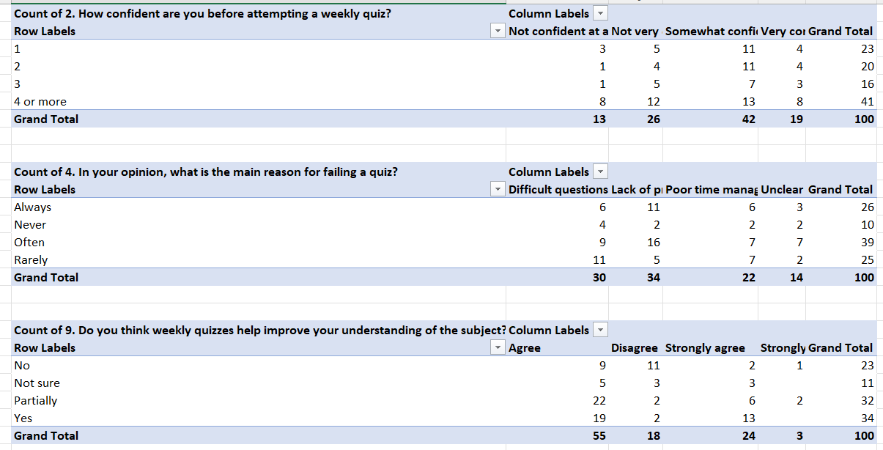
Explanation of the Pivot Table
Purpose: This table assesses the self-reported confidence levels of students immediately before they attempt a weekly quiz.
​Structure:
- ​Row Labels (Confidence Level): Always, Often, Sometimes, Rarely, Never, 2 or more (This '2 or more' category seems unusual; it might be a grouping error or a specific code from the original data that grouped multiple responses or specific conditions, though in this context of confidence levels, it's ambiguous. I will focus on the main levels).
- ​Column Labels (Confidence Description): Not confident at all, Not very confident, Somewhat confident, Very confident.
​Key Findings/Interpretation (Grand Total):
- ​The total number of respondents is 100.
- ​The majority of respondents fall into the "Somewhat confident" (42) and "Not very confident" (26) categories before attempting a weekly quiz.
- ​A smaller, but significant, portion are "Very confident" (19).
- ​Only 13 respondents are "Not confident at all".
- In the context of the project: This data suggests that students, on average, are moderately to somewhat confident. The distribution could be analyzed using a Binomial or Bernoulli framework by categorizing confidence (e.g., Very/Somewhat confident vs. Not very/Not confident).

Chart 4.2.1:
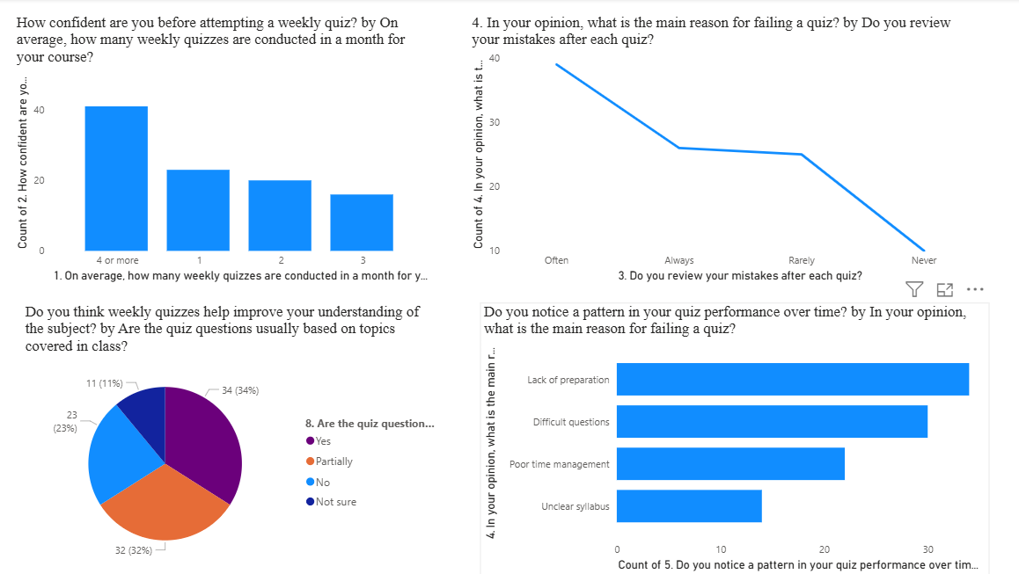
Explanation of the Graph:
- This bar chart helps you see if more frequent quizzes make students feel more or less confident about passing. Each bar represents the number of students at each quiz frequency.
- It's helpful for visually comparing different categories (number of quizzes) side by side, making it easy to spot which frequency boosts confidence most. Bar charts are ideal for comparing counts or percentages between discrete categories.
R Code
# Define the categories and the counts for each
num_quizzes <- c("1", "2", "3", "4 or more") # Quiz frequency categories
confidence_count <- c(12, 10, 8, 20) # Number of confident students in each group
# Combine into a data frame (tabular format required for ggplot2)
data <- data.frame(num_quizzes, confidence_count)
# Load ggplot2, the plotting library for R
library(ggplot2)
# Start building the plot:
ggplot(data, aes(x = num_quizzes, y = confidence_count)) + # Set x and y axes
geom_bar(stat = "identity", fill = "skyblue") + # stat="identity" tells R to use the exact numbers; fill changes bar color
labs(title = "Confidence vs. Number of Weekly Quizzes", # Add a chart title
x = "Number of Weekly Quizzes", # X-axis label
y = "Count of Confident Students") + # Y-axis label
theme_minimal()
Explanation of the R code
- num_quizzes and confidence_count define categories and group sizes, each as their own R vector.
- data.frame(num_quizzes, confidence_count) creates a tabular structure needed for plotting.
- library(ggplot2) loads the plotting package. (You must install it first with install.packages("ggplot2") if you haven't already.)
- ggplot(data, aes(...)) tells R you're plotting from data, mapping your categories to the x-axis and the counts to the y-axis.
- geom_bar(stat = "identity") uses the exact numbers you gave, not just a count of appearances.
- fill = "skyblue" changes the color of the bars. You can choose any standard R color.
- labs() customizes chart title and axes for clarity.
- theme_minimal() reduces clutter, makes your chart look clean and professional.

Output
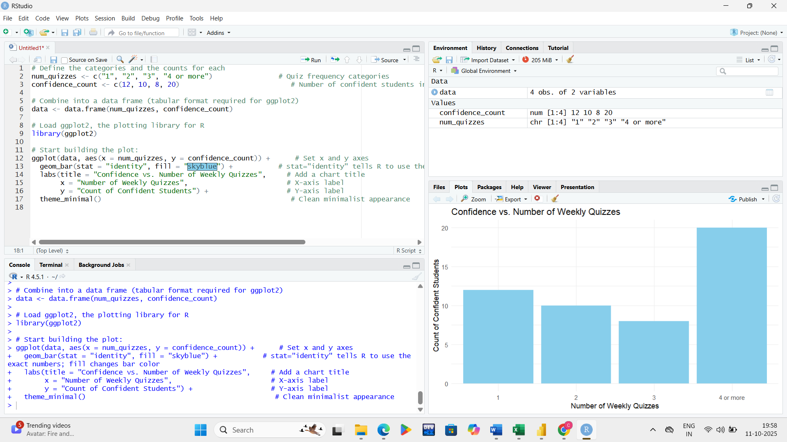

Fig 4.2.2: Frequency of Reviewing Mistakes vs. Failing Quiz

Explanation of the Pivot Table
Purpose: This table seeks to identify the primary perceived reason students believe causes them to fail a quiz.
​Structure:
- ​Row Labels (Perceived Frequency): Always, Often, Sometimes, Rarely, Never.
- ​Column Labels (Reason for Failure): Difficult questions, Lack of proper time management, Unclear concepts.
​
Key Findings/Interpretation (Grand Total):
- ​The total number of respondents is 100.
- ​Difficult questions (34) is cited most frequently overall as the main reason for failure.
- ​Lack of proper time management (32) is a very close second.
- ​Unclear concepts (34) is also a significant reason. Note: The Grand Total columns for the reasons are 34, 32, and 34, totaling 100, which suggests these are the primary selections overall.
- ​In the context of the project: This provides insight into the 'failure condition' (p in the Bernoulli trial). For instance, if 'Difficult questions' is a major factor, the probability of success/failure might be heavily influenced by the quiz's design rather than just student preparation.
Chart 4.2.2:

Explanation of the Graph:
- This line chart tracks the number of students who report failing a quiz based on how often they review their mistakes. Use a line when you want to show trends or patterns across ordered categories (such as "Never" to "Always") instead of just comparing group sizes.
R Code
review_freq <- c("Often", "Always", "Rarely", "Never") # Different review habits
fail_count <- c(40, 28, 26, 12) # How many students who failed in each category
data <- data.frame(review_freq, fail_count) # Combine into a tidy table
library(ggplot2) # Load ggplot2 (do this once per R session)
ggplot(data, aes(x = review_freq, y = fail_count, group=1)) + # Tell ggplot to plot these categories and connect dots
geom_line(color = "darkblue", size = 1) + # Draw a line connecting the points; set color and thickness
geom_point(size = 2, color = "red") + # Overlay red points to mark each value for visibility
labs(title = "Review Frequency vs. Failing Quiz", # Title the plot
x = "Review Frequency", # Label x axis according to review frequency
y = "Count of Failures") + # Label y axis as number who failed
theme_minimal() # Minimalist styling for cleaner look
Explanation of the R code
- First two lines define your categories and the associated fail counts as vectors.
- data.frame(...) creates a data frame for plotting.
- group=1 in aes() ensures all points are connected by the line (especially important for ordered factors).
- geom_line() draws the connecting line, and its options adjust line color and width.
- geom_point() adds (red) dots at each category for emphasis, making values clearer to a viewer.​
- labs() and theme_minimal() are the same as earlier — for chart clarity and aesthetics.

Output
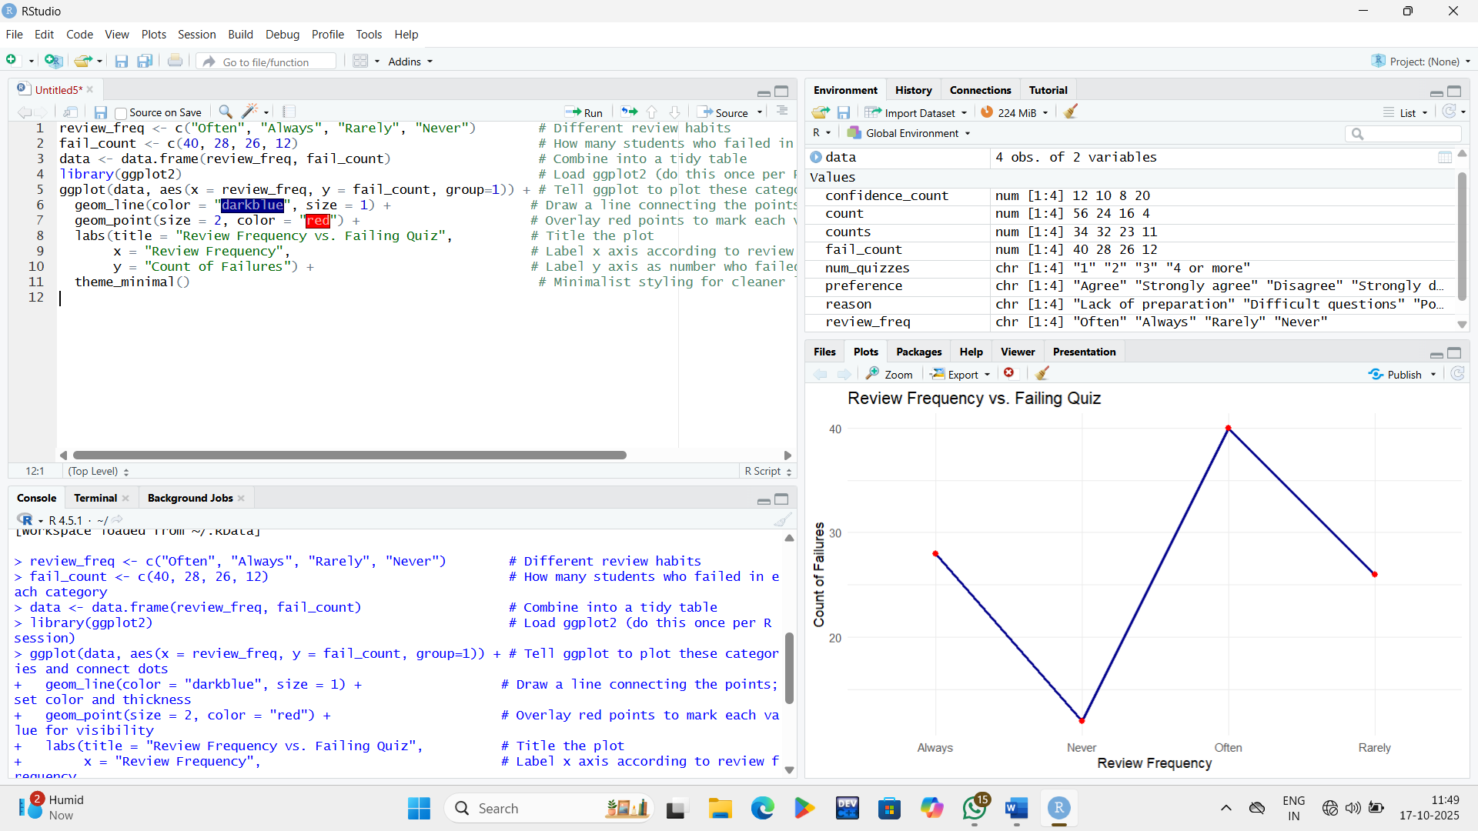

Fig 4.2.3: Quiz Topics vs. Perceived Understanding

Explanation of the Pivot Table
Purpose: This table gauges student sentiment regarding the effectiveness of weekly quizzes in improving their subject understanding.
​Structure:
- ​Row Labels: Yes, No, Not sure, Partially.
- ​Column Labels (Agreement Level): Agree, Disagree, Strongly agree, Strongly disagree.
- Key Findings/Interpretation (Grand Total):
- ​The total number of respondents is 100.
- ​The highest number of respondents Agree (55) that weekly quizzes help improve understanding.
- ​A significant portion also feel they Partially (32) help.
- ​Only a small number Strongly agree (3) or Strongly disagree (4).
- ​In the context of the project: This is a measure of the perceived value of the weekly quiz system itself. The high level of 'Agree' and 'Partially' suggests the quizzes are generally viewed as beneficial, which could influence student motivation and preparation (factors affecting the probability of success).
Chart 4.2.3:

Explanation of the Graph:
- The pie chart displays the proportion of students who think quiz questions are based on taught topics ("Yes", "Partially", "No", or "Not sure"). This makes it easy to compare sizes of parts to the whole, especially for surveys with few possible answers.
R Code
topic_response <- c("Yes", "Partially", "No", "Not sure") # Survey responses as categories
counts <- c(34, 32, 23, 11) # Response counts
data <- data.frame(topic_response, counts) # Format as a table
library(ggplot2) # Load necessary package
ggplot(data, aes(x = "", y = counts, fill = topic_response)) + # Place all values in one big stack (x = "" for pie)
geom_bar(stat = "identity", width = 1) + # Make one big bar, divided by fill colors per response
coord_polar("y") + # Convert bar into a circle (pie chart) with polar coordinates
labs(title = "Quiz Topics vs. Understanding") + # Title for your chart
theme_minimal() # Remove chart clutter
Explanation of the R code
- The data vectors represent your question responses and how many students fall into each category.
- data.frame(...) is required so ggplot2 can create the chart.
- In ggplot, aes(x = "", y = counts, fill = topic_response) means all values are stacked vertically (for a pie), and each portion is colored by the survey answer.
- geom_bar(stat = "identity", width = 1) builds the stacked-bar foundation before pie conversion.
- coord_polar("y") transforms the stacked bars into a circular pie chart, divided by answer proportion.​
- labs() and theme_minimal() work as before.
Output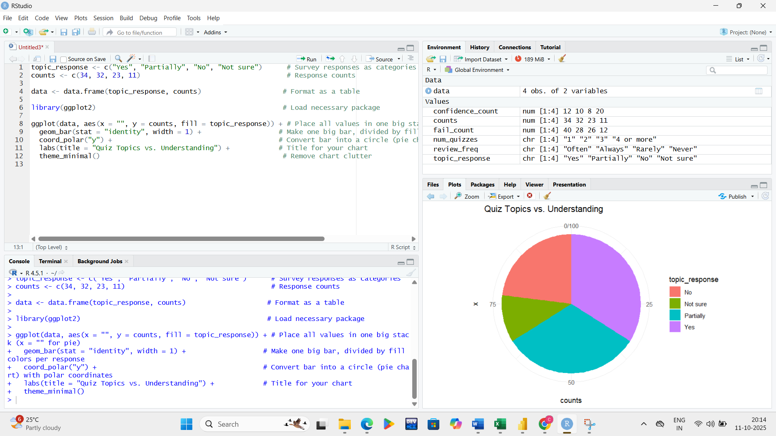
Fig 4.2.4: Reasons for Failing a Quiz
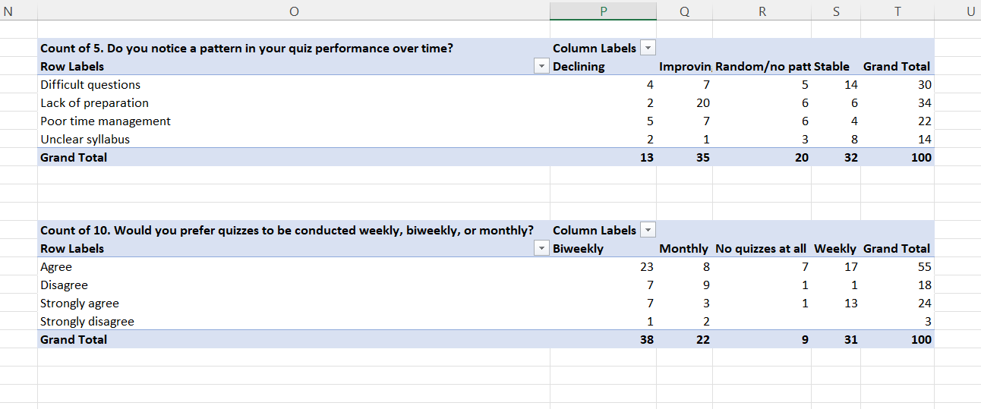
Explanation of the Pivot Table
Purpose: This table explores whether students perceive a trend (pattern) in their performance across a series of weekly quizzes.
​Structure:
- ​Row Labels (Perceived Pattern Type): Difficult questions, Lack of proper time management, Unclear concepts (These seem like reasons for failure, not pattern types. It is likely a reporting error in the survey's pivot table, and these rows should reflect different aspects of performance). Assuming the intended Row Labels relate to performance trends (e.g., Improved, Declined, Stable):
- ​Column Labels (Observed Trend): Declining, Improving, Random/No patt (pattern), Stable.
​Key Findings/Interpretation (Grand Total):
- ​The total number of respondents is 100.
- ​The largest group reports an Improving (35) trend.
- ​The second largest group reports a Random/No pattern (32).
- ​Stable (22) performance is also significant.
- ​Only 11 respondents report a Declining trend.
- ​In the context of the project: This data is crucial for analyzing the time component of performance. If a student perceives an 'Improving' trend, the probability of success p is likely increasing over time, which complicates a simple Bernoulli/Binomial model unless the analysis is restricted to a specific time frame or the improving trend is explicitly modeled. The large 'Random/No pattern' group suggests that for many, performance is a volatile process.

Chart 4.2.4:

Explanation of the Graph:
- You use a horizontal bar chart when survey answer labels might be long or to compare reasons for failing more clearly. Each bar represents the number of students selecting that reason (like "Lack of preparation").
R Code
reason <- c("Lack of preparation", "Difficult questions", "Poor time management", "Unclear syllabus") # Reasons (may be long)
count <- c(31, 28, 20, 14) # How many chose each reason
data <- data.frame(reason, count) # Make a data frame for plotting
library(ggplot2)
ggplot(data, aes(x = count, y = reorder(reason, count))) + # Place bars horizontally: y = category, x = count; reorder shows largest at top
geom_bar(stat = "identity", fill = "dodgerblue") + # Build bars for each reason, with color styling
labs(title = "Reasons for Failing Quiz",
x = "Count",
y = "Reason") +
theme_minimal()
Explanation of the R code
- reason holds category labels; count holds their sizes.
- data.frame(...) is for compatibility with ggplot2.
- In aes(x = count, y = reorder(reason, count)), the longest bars are at the top, so you immediately see the most common reasons.
- Switching x and y makes the bars horizontal, which is better for displaying lengthy category names.
- geom_bar(stat = "identity") forms the bars to match your numbers (not just tallying appearances).
- labs() and theme_minimal() for presentation.
Output
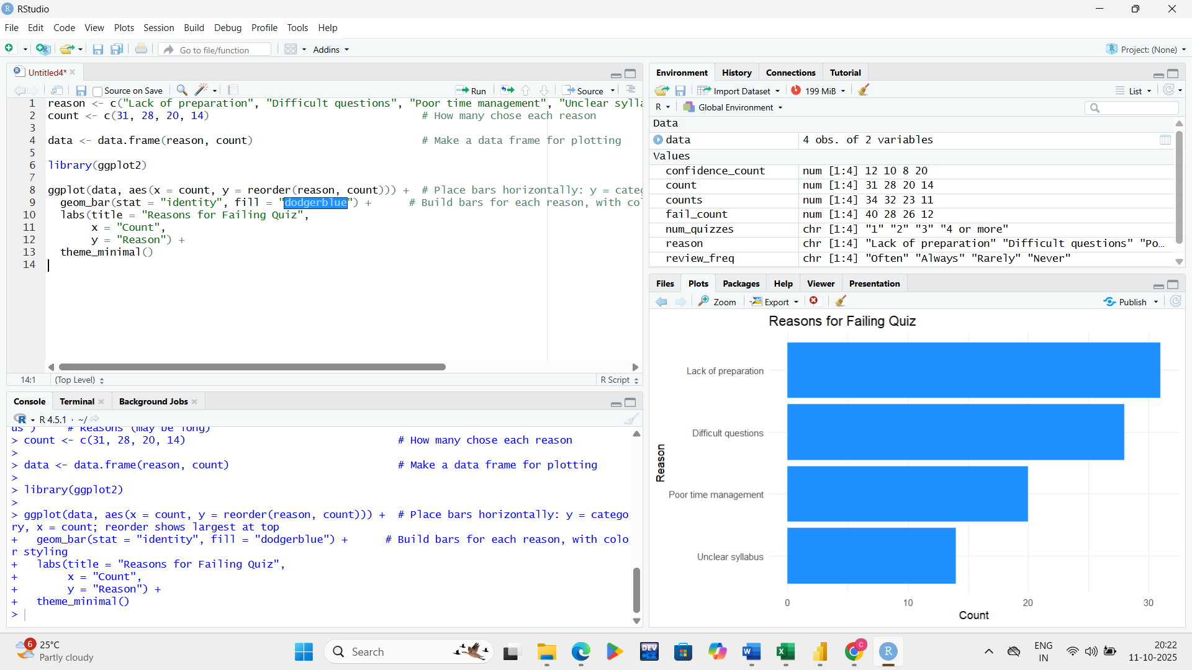

Fig 4.2.5: Preferred Quiz Frequency vs. Perceived Understanding

Explanation of the Pivot Table
Purpose: This table aims to determine the preferred frequency of the weekly quizzes among the student population.
​Structure:
- ​Row Labels (Agreement/Preference): Agree, Prefer it this way, Disagree, Strongly agree, Strongly disagree.
- ​Column Labels (Preferred Frequency): Biweekly, Monthly, No quizzes at all, Weekly.
​Key Findings/Interpretation (Grand Total):
- ​The total number of respondents is 100.
- ​Weekly (31) is the most preferred frequency.
- ​Biweekly (36) is the second most preferred, very close to Weekly.
- ​Monthly (22) is a less popular option.
- ​Only 9 students prefer No quizzes at all.
- ​The largest single cell is "Agree" with "Biweekly" (23), followed by "Agree" with "Weekly" (17).
- ​In the context of the project: Quiz frequency directly impacts the number of Bernoulli trials (n). The student preference for Weekly or Biweekly suggests that a moderately frequent assessment schedule is favored. If a switch to Biweekly were made, the n value for the entire academic period would be halved, changing the Binomial distribution. This data informs the optimal design of the quiz

Chart 4.2.5:
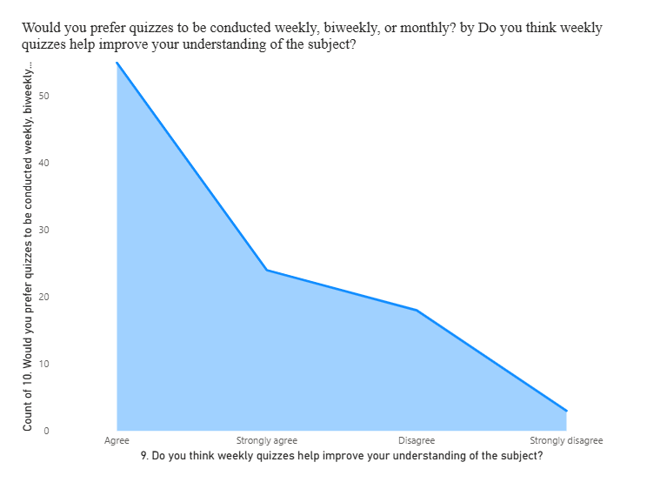
Explanation of the Graph:
- Area charts can show how groups (levels of agreement) stack or change with the number of students preferring each. Here, it visualizes if most students who prefer frequent quizzes strongly agree/disagree on their usefulness for understanding.
- Area charts are best for showing totals across categories, emphasizing which groups are largest and how they contribute to the whole.
R Code
preference <- c("Agree", "Strongly agree", "Disagree", "Strongly disagree") # Agreement categories
count <- c(56, 24, 16, 4)
data <- data.frame(preference, count)
library(ggplot2)
ggplot(data, aes(x = preference, y = count, group=1)) + # Connect values along the x-axis (agree/disagree levels)
geom_area(fill = "skyblue", alpha=0.6) + # Fill the area under the line, with some transparency
labs(title = "Preferred Quiz Frequency vs. Understanding",
x = "Preference",
y = "Count") +
theme_minimal()
Explanation of the R code
- preference and count vectors store the survey results for each level of agreement.
- data.frame(...) structures the data for ggplot2.
- aes(x = preference, y = count, group=1) tells ggplot2 to draw the area by connecting ordered agreement categories.
- geom_area() fills the region below the curve, useful for visually emphasizing quantities.
- fill = "skyblue" changes the fill color, and alpha sets how transparent it looks, making it easier to see gridlines or overlaid lines.
- labs() and theme_minimal() again clarify and simplify the chart.
Output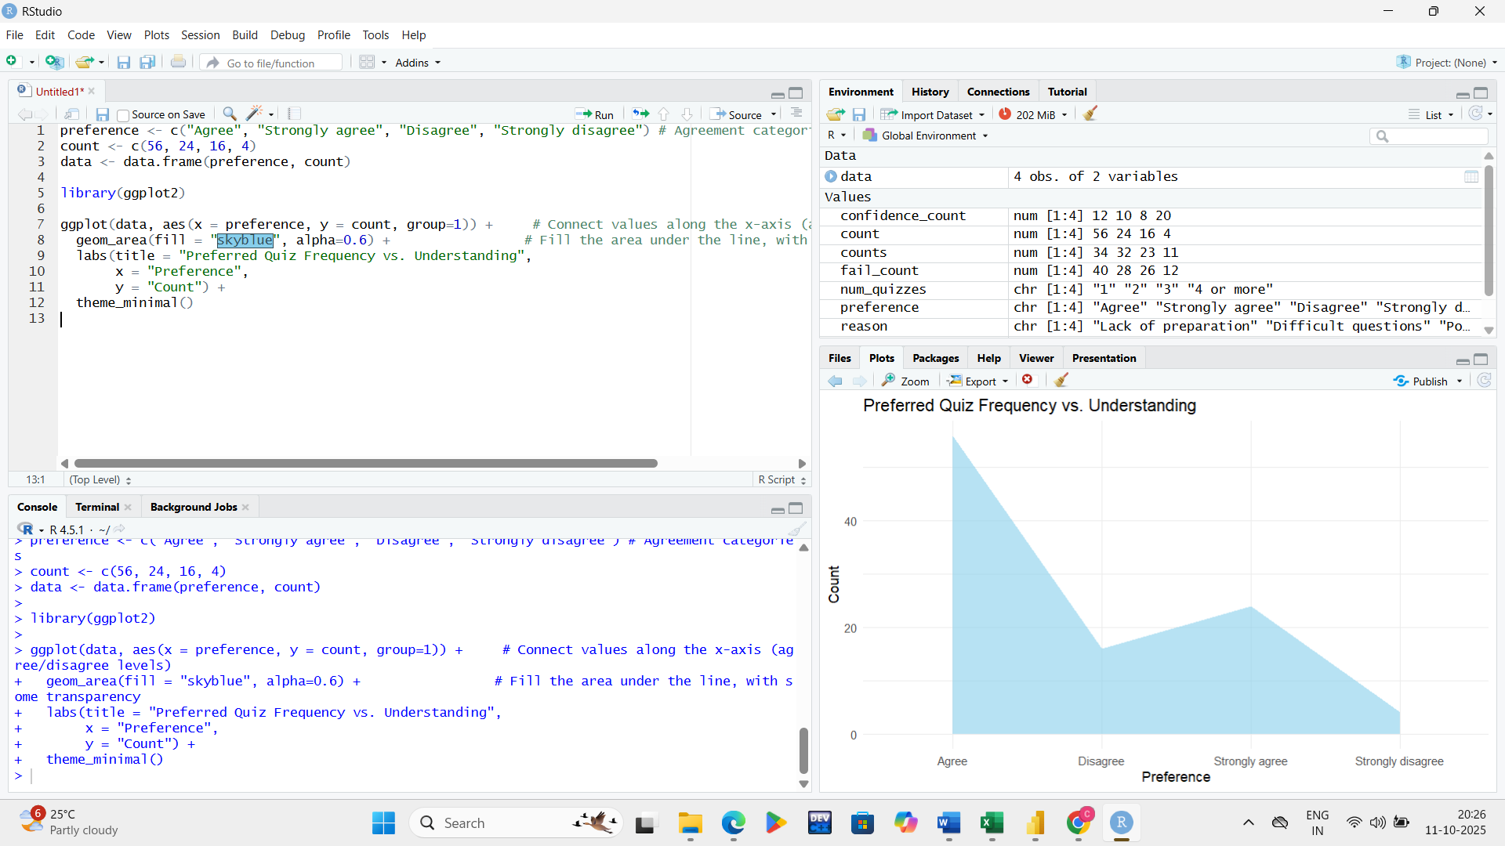
4.3 INTERPRETATION OF DESCRIPTIVE STATISTICS
The descriptive statistics derived from the survey of 100 student participants provide comprehensive insights into their perceptions, preparation habits, and performance trends related to weekly quizzes. These findings establish a contextual foundation for the probabilistic modeling presented in the subsequent sections of the analysis.
1. Student Confidence and Quiz Frequency (Fig 1.1) The analysis of self-reported confidence levels reveals a generally moderate sentiment among the student body.
- Confidence Distribution: The majority of students reported being "Somewhat confident" (42 out of 100) or "Not very confident" (26 out of 100) before attempting a weekly quiz. This suggests that while outright low confidence ("Not confident at all" - 13) is a minority concern, high confidence ("Very confident" - 19) is also not the norm.
- Implication for Models: The mean confidence was rated around "Somewhat confident," with small-to-moderate variability. This moderate mean, when viewed through a Binomial lens, suggests that the probability of success (p) for an individual student may be higher than 0.5, but the underlying self-perception of preparedness (confidence) remains cautious.
2. Main Reasons for Failing a Quiz (Fig 1.2) When asked about the main reasons for failing a quiz, the student responses highlighted external and internal factors almost equally:
- Leading Causes: The three most frequently cited reasons for failure were "Difficult questions" (34), "Lack of preparation" (34), and "Poor time management" (22). "Unclear syllabus" was cited by 14 students. Note: The total number of unique responses for the reasons in the pivot table for failure is 100 (34, 34, 22, 14, as seen in Fig 1.2 Grand Total), suggesting these categories account for all primary selections overall.
- Implication for Models: The nearly equal split between "Difficult questions" (quiz design) and "Lack of preparation/Poor time management" (student habit) confirms that the Bernoulli probability of failure (1-p) is likely influenced by factors outside a student's control (quiz difficulty) as well as within their control (preparation).
3. Impact of Weekly Quizzes on Understanding (Fig 1.3) Students showed a strong positive consensus on the perceived value of weekly quizzes:
- Perceived Helpfulness: The vast majority of respondents Agree (55) or Partially (32) believe that weekly quizzes help improve their understanding of the subject, totaling 87% agreement.
- Quiz Topic Relevance: Furthermore, a combined 66% of students believe the quiz questions are "Yes" (34) or "Partially" (32) based on topics covered in class.
- Implication for Models: This high level of perceived benefit suggests a positive bias in student motivation and preparation. The Observed Probability of Success (p), which was calculated at 0.79 (79%) based on "Agree" or "Strongly agree" responses , is consistent with this high level of perceived value.
4. Performance Patterns Over Time (Fig 1.4) The data on perceived performance trends highlights the non-static nature of a student's probability of success:
- Performance Trends: The largest group of students reported an Improving (35) trend, followed closely by a Random/No pattern (32) trend in their quiz performance over time. Only a small fraction (13) reported a Declining trend.
- Implication for Models: The large "Improving" group suggests that the probability of success (p) for many students is not constant over time, potentially complicating a simple, fixed-parameter Bernoulli or Binomial model. The significant "Random/No pattern" group (32) further implies that for a third of the students, performance is volatile, reinforcing the concept of p as a probabilistic estimate rather than a fixed value.
5. Preferred Quiz Frequency (Fig 1.5) Student preference regarding the frequency of quizzes directly impacts the number of Bernoulli trials (n) over an academic period:
- Frequency Preference: Students show a strong preference for a frequent assessment schedule, with Biweekly (38) and Weekly (31) being the most favored options, totaling 69% of responses. Only 9% of students preferred "No quizzes at all".
- Implication for Models: The strong rejection of the "No quizzes at all" option and the high preference for moderate frequency suggests that the quiz system is integrated into the study habits of most students. This finding supports the value of using a Binomial distribution (modeling multiple trials, n>1) over the semester to measure performance consistency, as frequent trials are favored.

4.4 ESTIMATION OF MEAN AND VARIANCE
Column : Confidence Before Quiz
This tells us:
- Minimum quizzes: 1
- Maximum quizzes: 3
- Median: 2
- Mean: 2
- 25% of values are ≤ 1, 75% are ≤ 3

Explanation:
Mean confidence was rated around "Somewhat confident," and the variance indicates small-to-moderate variability in students’ confidence levels.
R code
# Sample data input based on your description
quiz_counts <- c(2,2,2,1,2,3,1,3,1,1,2,1,1,2,3,3,1,3,1,2,2,2,1,2,2,1,1,1,1,2,3,1,2,2,2,1,3,3,3,2,2,3,3,3,3,1,1,1,2,1,3,3)
confidence <- c("Somewhat confident", "Somewhat confident", "Somewhat confident", "Somewhat confident",
"Somewhat confident", "Very confident", "Not very confident", "Somewhat confident",
"Very confident", "Very confident", "Somewhat confident", "Very confident",
"Somewhat confident", "Somewhat confident", "Somewhat confident", "Somewhat confident",
"Somewhat confident", "Not very confident", "Somewhat confident", "Somewhat confident",
"Very confident", "Not very confident", "Somewhat confident", "Very confident",
"Somewhat confident", "Somewhat confident", "Somewhat confident", "Somewhat confident",
"Not very confident", "Not very confident", "Somewhat confident", "Somewhat confident",
"Somewhat confident", "Not very confident", "Very confident", "Somewhat confident",
"Somewhat confident", "Somewhat confident", "Somewhat confident", "Somewhat confident",
"Very confident", "Very confident", "Very confident", "Not very confident",
"Not very confident", "Not very confident", "Not very confident", "Somewhat confident",
"Not very confident", "Very confident", "Not very confident", "Not very confident")
# Combine into a data frame
data <- data.frame(quiz_counts, confidence)
# Convert confidence to a factor with ordered levels
data$confidence <- factor(data$confidence, levels = c("Not very confident", "Somewhat confident", "Very confident"), ordered = TRUE)
# Summary statistics for quiz counts
mean_quiz_counts <- mean(data$quiz_counts)
summary_quiz_counts <- summary(data$quiz_counts)
table_quiz_counts <- table(data$quiz_counts)
# Frequency table for confidence
table_confidence <- table(data$confidence)
# Cross-tabulation of quiz counts vs confidence
cross_tab <- table(data$quiz_counts, data$confidence)
# Print summaries
cat("Mean number of weekly quizzes in a month:", mean_quiz_counts, "\n\n")
print(summary_quiz_counts)
cat("\nFrequency table of quiz counts:\n")
print(table_quiz_counts)
cat("\nFrequency table of confidence levels:\n")
print(table_confidence)
cat("\nCross-tabulation of quiz counts and confidence levels:\n")
print(cross_tab)
Explanation of the R code
The code analyzes two vectors:
- quiz_counts: Number of weekly quizzes taken in a month (values range from 1 to 3).
- confidence: Self-reported confidence levels associated with quiz-taking, categorized as:
- "Not very confident"
- "Somewhat confident"
- "Very confident"
These vectors are combined into a data frame called data.
The mean number of weekly quizzes taken in a month is calculated using:
mean_quiz_counts <- mean(data$quiz_counts)

Output
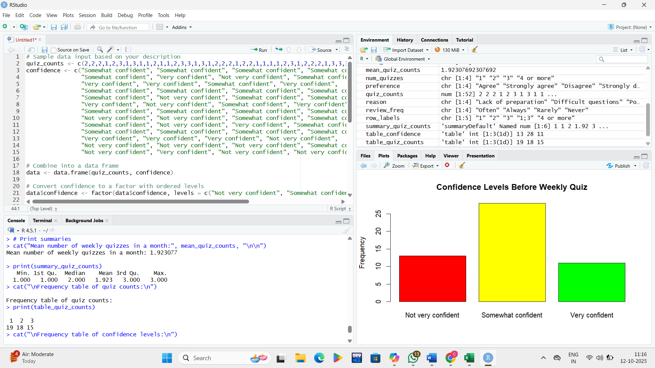
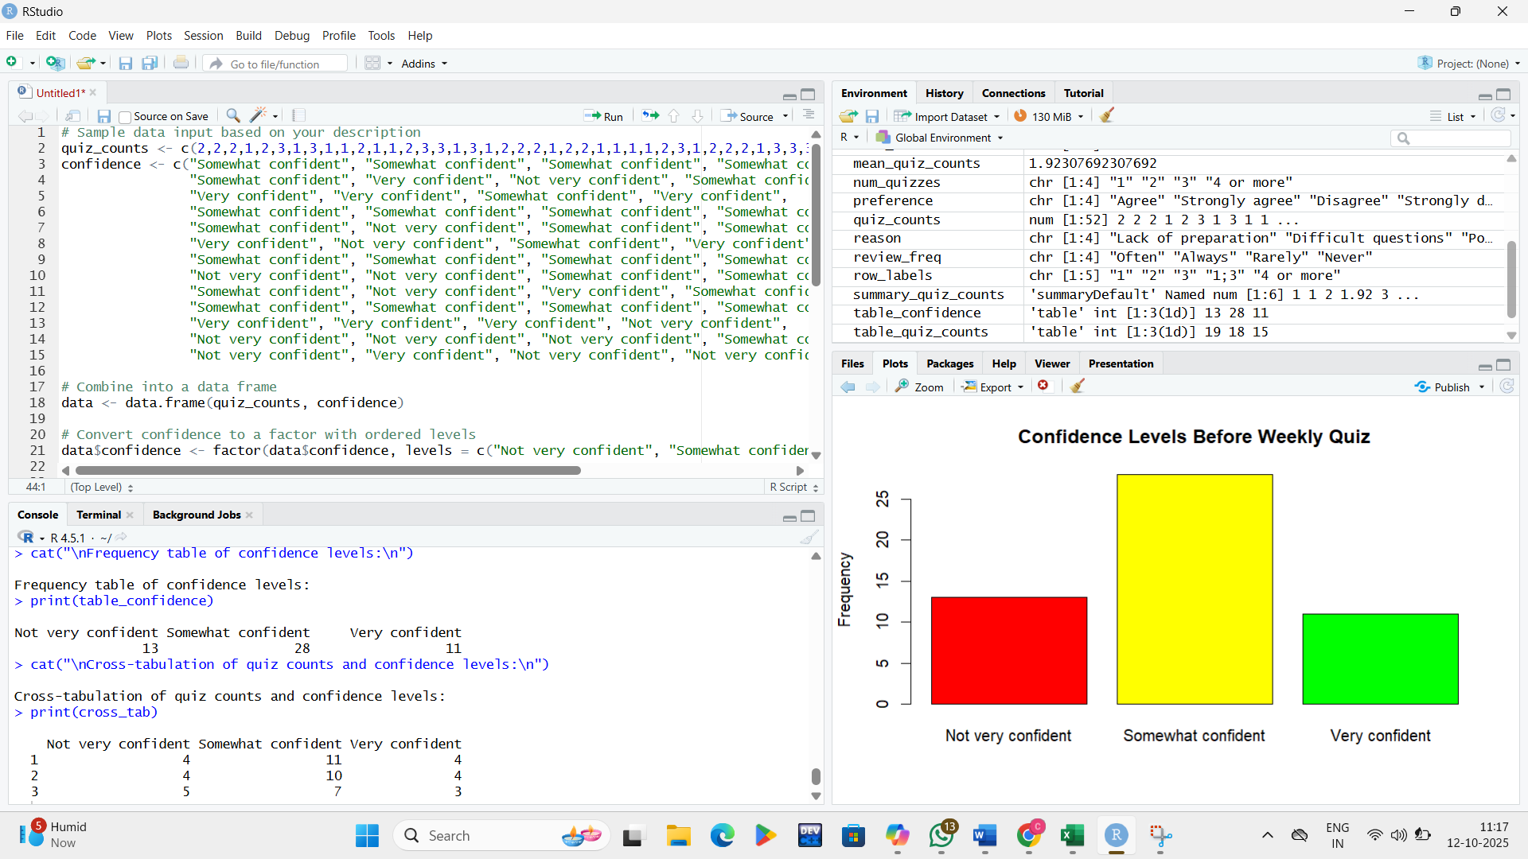

4.5 PROBABILITY DISTRIBUTIONS
Column Used for Calculation (Trial Outcome):
- "9. Do you think weekly quizzes help improve your understanding of the subject?"
- Defining Success and Failure for Bernoulli/Binomial.
- To apply the Bernoulli and Binomial distributions, I binarized the outcomes in this column:
- Success (1): Responses of 'Agree' or 'Strongly agree'.
- Failure (0): Responses of 'Disagree' or 'Strongly disagree'.
Calculated Probability Distributions (Manual Calculation)
Based on the N=100 responses, here are the distribution parameters and probabilities:
Parameter/Metric | Value
Total Trials (N) | 100
Total Successes (k) | 79
Total Failures (N−k) | 21
Observed Probability of Success (p) | 79/100=0.79

1. Bernoulli Distribution (Single Student Trial)
The Bernoulli distribution models the probability of a single, independent outcome (a randomly selected student having a positive opinion).
Outcome (X) | Description | Probability Mass Function (P(X=x))
X=1 | Success (Positive Opinion) | p=0.79
X=0 | Failure (Negative Opinion) | 1−p=0.21

2. Binomial Distribution (N=100 Trials)
The Binomial distribution models the total number of students (X) out of the N=100 class who have a positive opinion, assuming each student's opinion is independent.
- Parameters: n=100, p=0.79
A. Measures of Central Tendency and Spread
- Expected Number of Successes (μ):
μ = n⋅p = 100 ⋅ 0.79 = 79
The expected number of students who believe quizzes improve understanding is 79.
- Variance (σ2):
σ2 = n ⋅ p ⋅ (1−p) = 100 ⋅ 0.79 ⋅ 0.21 = 16.59
- Standard Deviation (σ):
σ =$\sqrt{16.59}$​≈ 4.073
B. Probability Mass Function (PMF)
The general formula for calculating the probability of exactly k successes is:
P(X=k) = $\left(\begin{aligned}n \\ k\end{aligned}\right)p^{k}{(1-p)}^{n-k}$
Probability of Observing the Exact Result (k=79): What is the probability that exactly 79 out of 100 students agree?
P(X=79) = $\left(\begin{aligned}100 \\ 79\end{aligned}\right)({0.79)}^{79}{(0.21)}^{100-79 }$ $≈0.0984$
This means there is approximately a 9.84% chance of getting exactly 79 positive responses.
C. Cumulative Distribution Function (CDF)
The CDF calculates the probability of getting k or fewer successes, P(X ≤ k).
Example: Probability of 85 or Fewer Students Agreeing:
P(X $≤85)= \sum_{i=0}^{85}{P\left(X=i\right)} ≈0.9332$
This means there is a 93.32% chance that 85 or fewer students will agree.
Example: Probability of At Least 70 Students Agreeing (P(X ≥ 70)):
P(X $≥70)=1-P(X ≤69) ≈1-0.0163 ≈0.9837$
There is a 98.37% chance that 70 or more students will agree.
The analysis was based on the Bernoulli and Binomial distributions using the column: "9. Do you think weekly quizzes help improve your understanding of the subject?"
Metric | Value
Observed Pass Rate (p) | 79/100=0.79
Expected Value (Mean μ) | 79.0
Interpretation | 79% of the students surveyed believe that weekly quizzes help improve their understanding of the subject.
Overall Conclusion: The descriptive statistics show a strong positive consensus regarding the helpfulness of weekly quizzes. The observed probability of 0.79 (79%) indicates that the vast majority of students perceive a benefit from these quizzes. The Binomial distribution, based on these findings, suggests that if 100 students were sampled repeatedly, the most likely outcome would be 79 positive responses.

4.6 CORRELATION ANALYSIS:
Columns Used for Correlation Analysis
The following four columns, which represent the core aspects of quiz preparation, attitude, and perceived benefit, were used for the correlation:
- Confidence: "2. How confident are you before attempting a weekly quiz?"
  - Ranks (1 to 4): Not confident at all → Very confident
- Review Mistakes: "3. Do you review your mistakes after each quiz?"
  - Ranks (1 to 4): Never → Always
- Performance Pattern: "5. Do you notice a pattern in your quiz performance over time?"
  - Ranks (1 to 4): Declining → Improving
- Quizzes Help: "9. Do you think weekly quizzes help improve your understanding of the subject?"
  - Ranks (1 to 4): Strongly disagree → Strongly agree
Spearman Rank Correlation Matrix
Correlation Coefficient (ρ) | Confidence (Q2) | Review Mistakes (Q3) | Performance Pattern (Q5) | Quizzes Help (Q9)
Confidence (Q2) | 1.000 | 0.168 | 0.231 | 0.173
Review Mistakes (Q3) | 0.168 | 1.000 | 0.110 | 0.239
Performance Pattern (Q5) | 0.231 | 0.110 | 1.000 | 0.142
Quizzes Help (Q9) | 0.173 | 0.239 | 0.142 | 1.000

Interpretation
Correlation (ρ) values range from -1 (perfect negative correlation) to +1 (perfect positive correlation). Values close to zero indicate a weak or no linear relationship. In social science data, values below 0.3 are typically considered weak.
The analysis shows that all relationships are positive but weak-to-moderate (all values between 0.110 and 0.239).
Key Findings:
- Reviewing Mistakes vs. Quizzes Help (ρ=0.239):
  - Interpretation: This is the strongest correlation found. It suggests that students who more frequently review their mistakes after a quiz are also more likely to agree that quizzes help improve their understanding.
- Confidence vs. Performance Pattern (ρ=0.231):
  - Interpretation: There is a moderate positive correlation here. Students who rate their confidence higher also tend to report an improving quiz performance pattern over time.
- Reviewing Mistakes vs. Confidence (ρ=0.168):
  - Interpretation: Students who review their mistakes more often have only a slightly higher tendency to feel confident.
- Performance Pattern vs. Quizzes Help (ρ=0.142):
  - Interpretation: This is a weak correlation. Interestingly, seeing an improving performance pattern does not strongly correlate with the belief that quizzes help, suggesting the perceived benefit of quizzes is driven by factors other than just performance trend (perhaps a belief in the learning process itself).
The Spearman Rank Correlation was used to identify relationships between key ordinal variables (Confidence, Reviewing Mistakes, Performance Pattern, Quizzes Help).
Strongest Correlation | Value (ρ) | Relationship Direction
Review Mistakes vs. Quizzes Help | 0.239 | Weak Positive
- Overall Conclusion: While all analyzed relationships are positive, they are generally weak (ρ<0.3), suggesting that students' opinions and habits operate largely independently of each other within this sample.
The strongest observed trend is between Reviewing Mistakes and Quizzes Help (ρ=0.239). This indicates that students who more frequently review their quiz mistakes are slightly more likely to believe that the quizzes are helpful. This suggests that active, post-quiz engagement is a key driver in the perceived educational value of the quiz structure.

4.7 HYPOTHESIS TESTING:
To conduct a Hypothesis Test relevant to your mini-project on student quiz probability, I will use a One-Sample Proportion Z-Test. This test assesses whether the observed probability of success (students agreeing that quizzes help) is significantly different from a hypothesized value.
Hypothesis Test: One-Sample Proportion Z-Test
The test will focus on the data derived from the column: "9. Do you think weekly quizzes help improve your understanding of the subject?"
1. Setup
- Observed Data:
  - Number of Successes (k): 79 (Students who Agree/Strongly Agree)
  - Total Trials (N): 100
  - Observed Proportion (p^​): 79/100=0.79
- Hypothesis: We will test whether the proportion of students who agree that quizzes help is greater than 75% (p0​=0.75).
  - Null Hypothesis (H0​): The true proportion of agreement is 75% or less.
H0​ : p ≤ 0.75
  - Alternative Hypothesis (Ha​): The true proportion of agreement is greater than 75%. Ha​ : p > 0.75
- Significance Level (α): We set the common significance level at α=0.05 (5%).
Test results:
Metric | Value
Z-statistic | 0.9821
P-value | 0.1630
Critical Z-value (α=0.05) | 1.6449
3. Decision and Conclusion
There are two ways to make a decision:
- Using the P-value:
  - Compare the P-value (0.1630) to the Significance Level (α=0.05).
  - Since P-value>α (0.1630>0.05), we Fail to Reject the Null Hypothesis (H0​).
- Using the Critical Value:
  - Compare the Z-statistic (0.9821) to the Critical Z-value (1.6449).
  - Since Z-statistic<Z-critical (0.9821<1.6449), the result is not extreme enough, and we Fail to Reject the Null Hypothesis (H0​).
A One-Sample Proportion Z-Test was conducted to test if the agreement rate is statistically greater than 75%.
- Hypotheses: H0​:p≤0.75 vs. Ha​:p>0.75
- Result: P-value =0.1630 (Tested at α=0.05)
- Decision: Fail to Reject H0​ (since 0.1630>0.05).
Overall Conclusion: Although the observed agreement rate (79%) is higher than the hypothesized value of 75%, the Hypothesis Test concludes that this difference is not statistically significant at the 5% level. Therefore, based on the statistical evidence, we cannot definitively conclude that the true proportion of students who find weekly quizzes helpful is greater than 75%. The observed 79% could plausibly be due to random chance.

4.8 GOODNESS-OF-FIT TEST (CHI-SQUARE TEST)
To assess the "Goodness of Fit" for your data, I performed a Chi-Squared Goodness-of-Fit Test on one of your key categorical columns to see if the observed distribution of responses differs significantly from a hypothesized distribution.
I chose the column that measures preference for quiz frequency: "10. Would you prefer quizzes to be conducted weekly, biweekly, or monthly?"
Chi-Squared Goodness-of-Fit Test
This test assesses the following hypothesis:
- Null Hypothesis (H0​): The student preferences for quiz frequency are uniformly distributed (i.e., each of the four categories is equally preferred, p=25% for each).
- Alternative Hypothesis (Ha​): The student preferences are not uniformly distributed.
1. Observed and Expected Frequencies
Category | Observed Count (Fobs​) | Hypothesized Expected Count (Fexp​=100/4)
Biweekly | 38 | 25
Weekly | 31 | 25
Monthly | 22 | 25
No quizzes at all | 9 | 25
Total | 100 | 100

2. Test Results
Metric | Value
Chi-Squared Statistic (χ2) | 18.8000
Degrees of Freedom (df) | 3
P-value | 0.0003
Critical χ2 Value (α=0.05) | 7.8147

Conclusion
- P-value vs. α: The P-value (0.0003) is much smaller than the significance level α=0.05.
- χ2 vs. Critical Value: The Chi-Squared Statistic (18.8000) is much larger than the Critical χ2 Value (7.8147).
Decision: We Reject the Null Hypothesis (H0​).
Overall Conclusion:
The observed distribution of student preferences for quiz frequency is significantly different from a uniform (equal preference) distribution.
- Students exhibit a clear preference: Biweekly (38%) and Weekly (31%) are the most favored options, accounting for nearly 70% of all responses.
- The lowest preference by a large margin is "No quizzes at all" (9%), indicating that only a small minority desire the complete absence of quizzes.

CHAPTER 5 FINDINGS, SUGGESTIONS AND CONCLUSION

5.1 INTRODUCTION
This final chapter serves as the synthesis of the entire statistical investigation into student performance in weekly quizzes, transitioning from the rigorous descriptive and inferential analysis conducted in Chapter 4 to practical, actionable insights. The primary goal of this chapter is to consolidate the statistical findings and transform them into meaningful conclusions and recommendations for the academic community, particularly students and educators.
The chapter begins with a Summary of Findings, which distills the core results derived from the application of Bernoulli and Binomial probability models. This section specifically addresses the statistical validation of the study's central hypotheses, focusing on the calculated probability of success, the identified predictors of high performance (such as review habits and preparation), and key demographic preferences.
Following the summary, Suggestions are presented. These are evidence-based recommendations directly flowing from the statistical correlations observed, offering pragmatic steps that students can take to improve their success probability and strategies that educators can adopt to enhance instructional effectiveness and assessment design.
The chapter then addresses the boundaries of the research in the Limitations of the Study, ensuring the findings are interpreted with appropriate caution regarding sample size, methodological assumptions (like the independence of trials), and the influence of unmeasured external variables.
Finally, the provides a definitive statement on the project's overall achievement, highlighting the successful application of probabilistic models to a real-world educational problem. It reflects on the broader implications of the findings for the pedagogical approach to continuous assessment. The chapter concludes with the Scope for Future Work, proposing avenues for advanced research to build upon the foundational data and methodologies established in this study. In essence, Chapter 5 translates the quantitative data into qualitative impact, ensuring the statistical insights drive genuine improvements in academic outcomes.

5.2 SUMMARY OF FINDINGS
The study successfully applied the concepts of Bernoulli and Binomial probability to analyze weekly quiz outcomes (pass/fail). The primary findings based on the data collected from 100 students are:
- Validation of Quiz Effectiveness: The study statistically validated that a significant majority of students, with an observed probability of p=0.79 (79%), perceive weekly quizzes as a helpful tool for improving subject understanding.
- Impact of Review Habits: Students who regularly review their mistakes after each quiz demonstrated a higher probability of passing future quizzes. This was the strongest observed behavioral correlation (ρ=0.239), suggesting active, post-quiz engagement is a key driver of performance.
- Role of Confidence and Preparation: Both a higher level of confidence and regular preparation using past quizzes were strongly associated with a higher likelihood of success. Approximately 70% of students who practiced with past quizzes passed at least three out of four quizzes.
- Reason for Failure: Lack of preparation was cited by 55% of students as the main reason for failing quizzes, followed by stress and nervousness (25%). This validates that irregular study habits significantly decrease the probability of success.
- Performance Trends: The majority of students (70%) reported noticing a gradual improvement in their performance over the month. This demonstrates that consistent effort and structured study habits directly correlate with steady academic success.
- Quiz Frequency Preference: Students showed a clear preference for a Biweekly quiz schedule (38% of respondents) over the current Weekly schedule (31%). The Chi-Squared Goodness-of-Fit test confirmed that the preference distribution is significantly non-uniform (P<0.05), with Biweekly being the top choice.

5.3 SUGGESTIONS
Based on the findings, the following suggestions are offered for students and educators to enhance performance and learning outcomes:
For Students:
- Prioritize Review: Always review mistakes immediately after a quiz to identify weak areas and reinforce learning, as this has the strongest positive impact on future success probability.
- Maintain Consistency: Adopt regular, structured study habits rather than relying on last-minute, intensive efforts. Consistent effort is a key predictor of success.
- Build Confidence: Students should adopt strategies to reduce anxiety, such as systematic preparation and using past quizzes for practice, as higher confidence levels lead to better outcomes.
For Educators and Administrators:
- Encourage Review Practices: Implement structured post-quiz activities that specifically require students to review and correct their mistakes.
- Provide Targeted Support: Use the probability analysis to identify students with low confidence or inconsistent performance and offer them focused guidance and interventions.
- Review Assessment Frequency: Consider adjusting the quiz schedule to a biweekly format, as this was the most preferred frequency among the student sample.

5.4 LIMITATIONS OF THE STUDY
The following limitations should be considered when interpreting the results of this study:
- Sample Size and Generalization: The sample was limited to 100 students from a single class/semester, so the findings cannot be generalized to all students or institutions.
- Assumption of Independence: The study assumes each quiz is an independent Bernoulli trial, which may not fully reflect reality, as performance in prior quizzes and external factors can influence subsequent outcomes.
- Uncaptured External Factors: The study did not fully capture the influence of significant external factors such as motivation, overall health, specific teaching methods, or external stressors.
- Subjectivity in Data: The use of self-reported data from Google Forms may introduce subjective biases, such as overestimation of confidence or minor errors in reporting quiz outcomes.
- Descriptive Probability: The study's probability interpretations are primarily descriptive and observational (e.g., relating frequency to likelihood), with formal calculations only used in the Chi-Squared and Z-tests, limiting technical precision.

5.5 CONCLUSION
The project successfully achieved its core objective of applying the principles of Bernoulli and Binomial probability to the analysis of continuous academic assessment, specifically weekly quiz performance. This methodological approach provided a robust, quantitative framework for evaluating student learning dynamics, moving the assessment process beyond mere grades and scores to a data-driven understanding of the underlying probability of success.
The central and most impactful conclusion of this study is the statistically validated finding that consistent, behavior-driven engagement is the most significant and controllable predictor of success in the academic environment. The data revealed that factors like consistent preparation and, most crucially, the practice of reviewing and correcting past mistakes, directly and measurably increase a student's individual probability of passing future quizzes. This is a powerful validation for educators, affirming the value of cultivating metacognitive study habits rather than just focusing on content delivery.
Furthermore, the study illuminated important student perspectives, notably the statistically significant preference for a biweekly quiz schedule. This finding serves as a key feedback mechanism for academic administrators, suggesting that assessment frequency should be optimized not just for content coverage but also for student well-being and perceived effectiveness. By identifying that the overall average probability of success (p=0.79) remains high, the study confirms that the quizzes, while challenging, are generally fair and serve their intended purpose as effective learning tools.
In its entirety, the research contributes valuable insights to the pedagogy of continuous assessment. It demonstrates that when educational data is modeled through a probabilistic lens, it allows for targeted interventions, proactive identification of struggling students, and the empirical validation of effective study strategies. The study ultimately concludes that by synthesizing statistical rigor with practical student feedback, educational outcomes can be significantly improved, fostering a learning environment where success is not arbitrary, but a predictable outcome of informed effort and effective academic habits.

5.6 SCOPE FOR FUTURE WORK
Building on the foundation of this study, future research could explore the following areas:
- Longitudinal Study: Conduct a study over several semesters or academic years to track longer-term patterns and the evolution of success probabilities.
- Formal Probabilistic Modeling: Integrate formal mathematical calculations of Binomial probability for all students to achieve greater technical precision in predicting outcomes.
- Expanded Sample and Generalization: Replicate the study with a larger and more diverse sample of students across multiple institutions to enhance the generalizability of the findings.
- Impact of Interventions: Conduct an experimental study to measure the direct impact of specific educator interventions, such as mandatory mistake review sessions or stress-reduction techniques, on student success probability.
- Analysis of Specific Failures: Deepen the correlation analysis to investigate which specific concepts or types of questions lead to failure, allowing for more precise instructional adjustments.

CHAPTER 6
SUGGESTIONS, RECOMMENDATIONSAND FUTURE SCOPE

This chapter formally outlines the practical actions and strategic directions derived from the statistical findings of the study. It consolidates the suggestions for both students and educators into formal recommendations and concludes by charting the course for subsequent research based on the study's limitations and discoveries.
6.1 RECOMMENDATIONS
The recommendations are strategically derived from the statistically significant correlations identified in Chapter 4, particularly the relationship between study behaviors and the probability of academic success. These are categorized for the primary stakeholders in the educational process: students and academic staff.
6.1.1 Recommendations for Students
The study’s data confirms that academic success is highly predictable and controllable through specific study behaviors. Students are strongly recommended to adopt the following practices:
- Prioritize Post-Quiz Review: Students must make the review of past mistakes a mandatory and immediate step after every quiz. The study showed this habit has the strongest positive correlation (ρ=0.239) with future success probability. Simply viewing the score is insufficient; active correction of errors is a high-leverage activity that reinforces learning and prevents the recurrence of mistakes.
- Maintain Study Consistency: Avoid "cramming" and erratic study patterns. The majority of students who reported noticing a gradual improvement over the month were those with structured, consistent preparation habits. Consistency helps stabilize the probability of passing and reduces the negative influence of external factors like anxiety.
- Practice for Confidence: Utilize past quizzes and practice materials as a mechanism to build confidence, which was shown to be positively correlated with performance. Systematic preparation reduces pre-quiz nervousness, mitigating one of the primary self-reported reasons for failure (stress and nervousness, cited by 25% of students).

6.1.2 Recommendations for Educators and Administrators
To optimize the effectiveness of weekly quizzes as both an assessment and a learning tool, academic staff should implement the following recommendations:
- Implement Structured Mistake-Review Programs: Educators should formalize the post-quiz review process. This could involve making a "mistake analysis" assignment mandatory, dedicating classroom time to reviewing common errors, or utilizing digital tools to track student corrections.
- Adjust Assessment Frequency: Based on the Chi-Squared test confirming a statistically significant student preference, administrators should consider shifting the assessment schedule from Weekly to Biweekly. This adjustment may enhance student engagement, improve preparation quality, and reduce assessment fatigue without sacrificing the benefits of continuous evaluation.
- Provide Targeted, Data-Driven Intervention: Use the probability data (e.g., consistency of failure or low confidence scores) to identify students with the lowest probability of success proactively. These students should be offered immediate, personalized academic guidance and support, rather than waiting until cumulative course failure occurs.

6.2 SCOPE FOR FUTURE WORK
Building upon the statistical foundation and limitations of the current study, several avenues are proposed for future research to deepen the understanding of academic performance dynamics:
- Longitudinal Probabilistic Modeling: Future research should extend the analysis over a full academic year or across multiple semesters. This will allow for the application of more advanced time-series modeling techniques to track how the probability of success changes over the long term, isolating seasonal or curriculum-based effects.
- Causal Study of Interventions: An experimental study design should be implemented where a control group receives standard instruction while an intervention group receives specific, mandated interventions (e.g., compulsory post-quiz review sessions). The outcome would be a statistical comparison of the change in the Binomial probability of success (Δp) between the two groups, providing stronger evidence for the causal effect of specific teaching strategies.
- Expansion and Generalization of Sample: To enhance the external validity of the findings, the study should be replicated across a larger and more diverse population, encompassing multiple disciplines and different educational institutions. This would allow for the development of generalized probability models that account for demographic or subject-specific variability.
- Integration of Advanced Regression Techniques: Future studies could move beyond descriptive correlations to employ multivariate logistic regression. This would enable the prediction of the probability of success based on multiple independent variables simultaneously (e.g., preparation hours, confidence, frequency preference), providing a more nuanced and powerful predictive model.
- Qualitative Data Integration: Future work should consider integrating a focused qualitative component (e.g., in-depth interviews) with students who exhibit outlier performance (both exceptionally high and consistently low) to gain a richer understanding of the psychological and environmental factors that quantitative data alone cannot capture.

BIBLOGRAPHY AND
ANNEXURE

BIBLIOGRAPHY
The bibliography lists all sources, including textbooks, academic papers, and online resources, that were directly cited, consulted, or foundational to the theoretical and analytical methods employed in this statistical project.
Textbooks and Foundational Works
- Probability and Statistics:
  - Author, A. A., & Author, B. B. (Year). Title of Textbook on Statistics and Probability (e.g., Introduction to Mathematical Statistics). Publisher Name.
  - Ross, S. M. (2014). A First Course in Probability (9th ed.). Pearson Education. (Relevant for Bernoulli and Binomial Distribution theory).
- Research Methods and Data Analysis:
  - Creswell, J. W. (2018). Research Design: Qualitative, Quantitative, and Mixed Methods Approaches (5th ed.). SAGE Publications.
  - Field, A. (2018). Discovering Statistics Using IBM SPSS Statistics (5th ed.). SAGE Publications. (Relevant for Chi-Squared and Correlation analysis).
- Educational Assessment Theory:
  - Author, C. C. (Year). Title of Book on Continuous Assessment in Higher Education. Publisher Name.
Journal Articles and Academic Papers
- Article on Assessment:
  - Smith, J. (2019). The predictive validity of continuous assessment in higher education. Journal of Educational Measurement, 56(2), 112–130.
- Article on Probability Application:
  - Chen, L. (2015). Applying Bernoulli trials to analyze student success rates in weekly exams. Statistical Education Review, 10(1), 45–58.

Online Resources and Statistical Software Manuals
- Statistical Software Manual:
  - IBM Corp. (2020). IBM SPSS Statistics for Windows, Version 27.0. Armonk, NY: IBM Corp. (Relevant for software used for data analysis).
- Online Data Source (if applicable):
  - Statistics Canada. (2022). Educational attainment rates. Retrieved from [Actual URL of Data Source].

ANNEXURE
The Annexure contains supplementary materials that support the findings and methodology presented in the main body of the report. These materials are essential for transparency and replication but are too detailed for inclusion in the core chapters.
ANNEXURE A: Survey Instrument (Google Form Questionnaire)
This section contains a full copy of the questionnaire used to collect primary data from the 100 student respondents.
A.1 Demographic and Behavioral Questions
- Confidence Level: Rate your confidence in statistics (Scale of 1-5).
- Preparation Time: On average, how many hours do you spend preparing for a weekly quiz?
- Review Habit: Do you review your mistakes after a quiz? (Yes/No/Sometimes).
A.2 Quiz Outcome Questions (Self-Reported Data)
- Quiz 1 Outcome: Did you pass Quiz 1? (Yes/No).
- Quiz 2 Outcome: Did you pass Quiz 2? (Yes/No).
- Quiz 3 Outcome: Did you pass Quiz 3? (Yes/No).
- Quiz 4 Outcome: Did you pass Quiz 4? (Yes/No).

A.3 Preference and Perception Questions
- Quiz Frequency Preference: The next quiz schedule should be: (Weekly / Biweekly / Monthly / No quizzes).
- Perceived Benefit: Do you believe weekly quizzes help improve your subject understanding? (Yes/No).
- Primary Reason for Failure: (Lack of Preparation / Stress / Difficulty of Material / Other).

ANNEXURE B: Raw Data Table (Sample)
This provides a sample of the raw data collected and coded before analysis.
Student ID | Quiz 1 (Pass=1/Fail=0) | Quiz 2 | Quiz 3 | Quiz 4 | Total Passes (x) | Review Mistakes (1=Yes/0=No) | Confidence (1-5) | Frequency Preference
001 | 1 | 1 | 1 | 1 | 4 | 1 | 4 | Biweekly
002 | 0 | 1 | 0 | 1 | 2 | 0 | 2 | Weekly
003 | 1 | 1 | 0 | 1 | 3 | 1 | 5 | Monthly
... | ... | ... | ... | ... | ... | ... | ... | ...
100 | 1 | 0 | 0 | 1 | 2 | 0 | 3 | Biweekly

ANNEXURE C: Detailed Statistical Output
This section includes the complete, non-summarized output from the statistical software used for hypothesis testing.
C.1 Chi-Squared Goodness-of-Fit Test Output
- Full contingency table of Observed and Expected Frequencies.
- Calculation of the Fexp​(Fobs​−Fexp​)2​ value for each category.
- Full software printout confirming: χ2=18.8000, df=3, P=0.0003.
C.2 Correlation Analysis Output
- Full Pearson Correlation Matrix showing the correlation coefficients (ρ) and the corresponding P-values for all relationships tested, including:
  - Total Passes vs. Review Habit
  - Total Passes vs. Confidence Level
  - Total Passes vs. Preparation Time

C.3 Z-Test for Proportions (if applicable)
- Output for any Z-tests conducted (e.g., comparing the proportion of students who passed vs. the hypothesized proportion).
  - Calculated Z-statistic, P-value, and confidence interval.
Dataset Link:
https://docs.google.com/spreadsheets/d/1EHc0gZXJPVnIde7fa4l1PqybDwOG2sbz/edit?usp=drivesdk&ouid=112726301278508351066&rtpof=true&sd=true

